Department of DEFENSE INTEGRATED Program Management EVMS INterpretation guide

DRAFT – NOT FOR RELEASE – VERSION 6.0
OUSD AT&L (PARCA)
September 2014

DOCUMENT VERSION CONTROL LOG

Document Version | Change Description | Owner | Date
Draft – Not for Release. | Guideline Description, Strategic Intent, Attributes, Work Products, Glossary, and Reference Documents w/o Section narratives. | PARCA | 05-21-2014
Draft – Not for Release V1. | Revised subsection titles in Strategic Intent and added Management Value and Version Control Log. | PARCA | 05-28-2014
Draft – Not for Release V2. | Inserted narrative for the Foreword, Introduction, and Process Area Overviews, corrected business system references. | PARCA | 06-17-2014
Draft – Not for Release V3. | Incorporated comments and graphics resulting from the adjudication meeting held on July 21 – 28, 2014. | PARCA | 08-18-2014
Draft – Not for Release V4. | Incorporated comments and updated figures based on Adjudication Team meetings held August 25 -29, 2014. | PARCA | 09-05-2014
Draft – Not for Release V5. | Incorporated updated figures and glossary changes based on Adjudication Team meetings held August 25 -29, 2014. | PARCA | 09-10-2014
Draft – Not for Release V6. | Incorporated agreed upon changes from Adjudication Team meetings held September 18-19, 2014. | PARCA | 09-22-2014

FOREWORD
Earned Value Management (EVM) is one of the Department of Defense’s (DoD) and industry's most powerful program management tools. Government and industry program managers use EVM to assess cost, schedule and technical progress on programs and to support agile decision making as they navigate the day-to-day constraints and risks that all DoD programs face.

The Office of Performance Assessment and Root Cause Analysis (PARCA) is the principal DoD office for conducting performance assessments and root cause analyses of Major Defense Acquisition Programs (MDAPs) as statutorily required by the Weapon Systems Acquisition Reform Act of 2009, Public Law 111-23. A key element of PARCA's statutory responsibility is to evaluate MDAP performance using EVM metrics for cost, schedule, and technical performance. In support of this legislative responsibility, PARCA is also the single voice accountable for EVM performance, oversight, and governance across the DoD.

The Defense Contract Management Agency (DCMA) is responsible for reviewing EVMS plans and for verifying initial and continuing contractor compliance with DoD EVMS criteria. The contracting officer does not retain this function (DFARS Subpart 242.302(S-71) (reference 6). The Navy Supervisor of Shipbuilding (SUPSHIP) has the responsibility and authority to conduct EVMS surveillance activities, and the requirement to coordinate with DCMA and NAVSEA HQ stakeholders, for the contracts under the SUPSHIP’s cognizance. The Intelligence Community (IC) is excepted from the requirement to delegate EVMS-related Contract Administration Functions to DCMA.

This Guide contains the DoD strategic requirements for the interpretation of the 32 guidelines in the Electronic Industries Alliance Standard-748 EVMS (EIA-748) by contractors where an EVMS requirement is applied and will be used as the basis for how DoD Components assess EVMS compliance with the guidelines. It was developed in collaboration with DoD EVMS experts from Office of the Secretary of Defense, the Services, and the Agencies and organizations responsible for conducting EVMS compliance reviews (e.g. DCMA, IC, Navy SUPSHIP, and Defense Contract Audit Agency). The policy directly supports two of the seven focus areas included in the Office of the Under Secretary of Defense for Acquisition, Technology, and Logistics (OSD(AT&L)) Better Buying Power (BBP) initiative launched in June 2010 (reference 22): (1) Achieve Affordable Programs and (2) Control Costs Throughout the Product Lifecycle. The following strategies underlie the content of this policy:
- Reduce the implementation burden associated with demonstrating compliance with the EIA-748 by promoting consistent application of EVMS compliance assessments across DoD.
- Emphasize the need to establish clear and measurable technical objectives for planning, tracking, and managing the baseline plan.
- Establish an understanding of how the implementation of program-unique management practices can be consistent with broader EVMS guideline characteristics that support various ways of being compliant.

Table of Contents
1 INTRODUCTION 6
1.1 Purpose of Guide 6
1.2 EVM Policy 6
1.3 EVMS Compliance 7
1.4 Content and Format of Guide 8
2 INTEGRATED PROGRAM MANAGEMENT EVMS GUIDELINES 10
2.1 Organization Category 10
2.1.1 Overview of Organizing Category and Guidelines 10
2.1.1.1 Guideline 1: Define Program WBS 12
2.1.1.2 Guideline 2: Define Program OBS 14
2.1.1.3 Guideline 3: Integrate Subsidiary Management Processes 16
2.1.1.4 Guideline 4: Identify Overhead Management 18
2.1.1.5 Guideline 5: Integrate WBS/OBS to Create Control Accounts 19
2.2 Planning, Scheduling, and Budgeting Category 21
2.2.1 Overview of Planning, Scheduling, and Budgeting Category and Guidelines 21
2.2.1.1 Guideline 6: Scheduling Work 22
2.2.1.2 Guideline 7: Identify Products and Milestones for Progress Assessment 25
2.2.1.3 Guideline 8: Establish the Performance Measurement Baseline 26
2.2.1.4 Guideline 9: Authorize and Budget by Cost Elements 29
2.2.1.5 Guideline 10: Determine Discrete Work and Objective Measures 31
2.2.1.6 Guideline 11: Sum WP/PP Budgets to Control Account 34
2.2.1.7 Guideline 12: Level of Effort Planning and Control 35
2.2.1.8 Guideline 13: Establish Overhead Budgets 37
2.2.1.9 Guideline 14: Identify MR and UB 39
2.2.1.10 Guideline 15: Reconcile to Target Costs 41
2.3 Accounting Considerations Category 43
2.3.1 Overview of Accounting Considerations Category and Guidelines 43
2.3.1.1 Guideline 16: Record Direct Costs 45
2.3.1.2 Guideline 17: Summarize Direct Costs by WBS Elements 47
2.3.1.3 Guideline 18: Summarize Direct Cost by OBS Elements 48
2.3.1.4 Guideline 19: Record/Allocate Indirect Costs 50
2.3.1.5 Guideline 20: Identify Unit and Lot Costs 52
2.3.1.6 Guideline 21: Track and Report Material Cost/Quantities 54
2.4 Analysis and Management Reporting Category 59
2.4.1 Overview of Analysis and Management Reporting Category and Guidelines 59
2.4.1.1 Guideline 22: Calculate Schedule Variance and Cost Variance 60
2.4.1.2 Guideline 23: Analyze Significant Variances 62
2.4.1.3 Guideline 24: Analyze Indirect Cost Variances 65
2.4.1.4 Guideline 25: Summarize Performance Data and Variances for Management Reporting 66
2.4.1.5 Guideline 26: Implement Corrective Actions 67
2.4.1.6 Guideline 27: Maintain Estimate at Completion 68
2.5 Revisions and Data Maintenance Category 71
2.5.1 Overview of Revisions and Data Maintenance Category and Guidelines 71
2.5.1.1 Guideline 28: Incorporate Changes in a Timely Manner 72
2.5.1.2 Guideline 29: Reconcile Budgets 74
2.5.1.3 Guideline 30: Control Retroactive Changes 76
2.5.1.4 Guideline 31: Prevent Unauthorized Revisions 78
2.5.1.5 Guideline 32: Document PMB Changes 80
3 GLOSSARY 81
4 REFERENCE DOCUMENTS 97

Table of Figures

Figure A: DoD IPM EVMS II Guideline Format 9
Figure B: Example Program WBS 13
Figure C: Example Program OBS 15
Figure D: Integration of the WBS and OBS 20
Figure E: Horizontal and Vertical Integration in the IMS 23
Figure F: Relationship between Integrated Master Schedule & Manufacturing/Enterprise Planning System 24
Figure G: Initial Baseline Planning 27
Figure H: Time Phasing the PMB 28
Figure I: Notional Work Authorization and Control Account EOC Relationship 30
Figure J: Example of Application of Indirect Rates to Direct Costs 38
Figure K: Budget Hierarchy and Summarization 42
Figure L: Typical EVMS and Material Accountability 57

INTRODUCTION

Purpose of Guide

Earned Value Management (EVM) is a widely accepted industry best practice for program management that is being used across the Department of Defense (DoD), the Federal government, and the commercial sector. An EVM System (EVMS) is the integrated management control system that integrates a program’s work scope, schedule, and cost elements for optimum program planning and control. Government and industry program managers use EVM as a program management tool to provide joint situational awareness of program status and to assess the cost, schedule, and technical performance of programs. To be useful as a program management tool, program managers must incorporate EVM into their acquisition decision-making processes; the EVM performance data must be accurate, reliable, and timely; and the EVMS must be implemented in a disciplined manner consistent with the 32 guidelines prescribed in Section 2 of the Electronic Industries Alliance Standard-748 EVMS (EIA-748) (reference 33), hereafter referred to as “the 32 guidelines”.

The purpose of the DoD Integrated Program Management EVMS Interpretation Guide (IPM EVMS II) is to facilitate a common understanding of the interpretation of the guidelines. It will serve as the central EVMS interpretive guidance for all DoD Components as a source of clarification and information in accordance with the EVMS requirements in DFARS 234.203 (reference 5).

The IPM EVMS II contains the overarching DoD interpretation of the 32 guidelines where an EVMS requirement is applied. The Guide provides the DoD Strategic Intent behind each guideline as well as the specific attributes required in a compliant EVMS. Those attributes are the general qualities of effective implementation that are tested in support of determining EVMS compliance as it relates to the 32 guidelines. As applicable, the DoD Strategic Intent section may clarify where differences in guideline interpretation exist for development and production type work. The Guide will be used as the basis for how cognizant DoD agencies develop and maintain test step processes to assess EVMS compliance with the guidelines. Agencies charged with conducting initial and continuing EVMS compliance activities will establish amplifying agency procedures in the use of this Guide to include the development of specific testing protocols for the attributes associated with each of the 32 guidelines.

EVM Policy

The Office of Management and Budget (OMB) Circular A-11 (reference 31), and the Federal Acquisition Regulation (FAR) (references 16 and 17) require federal government agency contractors to establish, maintain, and use an EVMS that is compliant with the 32 guidelines on all major capital asset acquisitions. Based on these federal regulations, the DoD established DFARS 234.201 (reference 5), which prescribes application of an EVMS on any contract, to include subcontracted effort, via the DFARS 252.234-7002 EVMS clause (reference 8). When EVM reporting is contractually required, the contractor must submit to the government an Integrated Program Management Report (IPMR) (DI-MGMT-81861) (reference 11) to report program cost and schedule performance data.

In accordance with the EVMS requirements in the DFARS 234.203 (reference 5), contractors are required to use an EVMS that has been formally determined by the Cognizant Federal Agency (CFA) to be compliant with the 32 guidelines. When DoD is the CFA the Defense Contract Management Agency (DCMA) is responsible for determining EVMS compliance, with the exception of the Intelligence Community (IC). The contracting officer does not retain this function (DFARS Subpart 242.302(S-71) (reference 6). In accordance with July 2007 and August 2011, DoD memorandums (references 28 and 25), DoD Components in the IC are exempted from delegating EVMS authorities to DCMA. As structured within the DoD, the Navy Supervisor of Shipbuilding (SUPSHIP) has the responsibility and authority to conduct EVMS surveillance activities, and the requirement to coordinate with DCMA and NAVSEA HQ stakeholders, for the contracts under the SUPSHIP’s cognizance.

EVMS Compliance

A properly implemented EVMS will provide internal controls and formal processes for managing any acquisition within the DoD. These controls and program management processes will ensure both contractor and government program managers, as well as other government stakeholders, receive reliable and consistent contract performance data that:
- Relates time-phased budgets to specific contract tasks and/or statements of work
- Objectively measures work progress
- Properly relates cost, schedule, and technical accomplishment
- Allows for informed decision making and corrective action
- Is valid, timely, and auditable
- Allows for statistical estimation of future costs
- Supplies managers at all levels with appropriate program status information, and
- Is derived from the same EVMS the contractor uses to manage the contract.

The routine use of generally accepted management best practices and typical business management systems should already be firmly embedded into the contractor’s culture and business processes. Adding the EVM requirement to established program management business disciplines should not necessitate a major reorganization or refitting of current processes. It is expected that contractors will implement an EVMS by leveraging existing management processes and tools that are already used to conduct business.

The DoD requires that the management system and processes (i.e. tools, techniques and procedures) used by the contractor’s program management staff be formally documented in either a stand-alone EVM System Description (SD) or in a set or series of integrated process descriptions/procedures that describe the contractor’s approach to a compliant EVMS. This documentation will describe how the contractor’s business processes meet the intentions of the 32 guidelines and the DoD Strategic Intent for each guideline as described in this Guide.

As part of compliance assessments, contractors are expected to both explain and demonstrate how the integrated parts of the EVMS are used to comply with the 32 guidelines. There are three steps for evaluating compliance: (1) assess whether the contractor’s EVM SD adequately documents how its system meets the intent of the 32 Guidelines, (2) evaluate the contractor’s ability to demonstrate the EVMS implementation as described in the SD and supplemental procedures, and (3) ensure the EVMS is providing timely, reliable and accurate data. Compliance is determined based upon the results of all three steps.

Contractors are required to demonstrate compliance with the 32 guidelines regardless of EVM reporting requirements defined in the Contract Data Requirements List (CDRL). The flowdown of an EVMS requirement to a Subcontractor requires special consideration to ensure Subcontractor compliance with the 32 guidelines and for the Prime to incorporate Subcontractor EVM data into its EVMS. It is incumbent upon the Prime contractor to develop and demonstrate an effective methodology for managing the integration of its Subcontractors into their EVMS.

Content and Format of Guide

The DoD IPM EVMS II contains four sections. Section 1.0, the Introduction, provides the purpose of this Guide, an overview of EVM policy, a brief description of EVMS compliance assessments, and a synopsis of the overall content and format of the Guide.

Section 2.0 contains the 32 Guidelines in five categories:
- Organization – guidelines 1 through 5,
- Planning, Scheduling, and Budgeting – guidelines 6 through 15,
- Accounting Considerations – guidelines 16 through 21,
- Analysis and Management Reporting – guidelines 22 through 27, and
- Revisions and Data Maintenance – guidelines 28 through 32.

This section provides the guideline interpretations. It describes the purpose, management value, intent, attributes, and typical work products of the 32 guidelines. The work products listed are not all-inclusive and the terminology used is notional. In some instances, the work product could be a process or EVMS subsystem mapping document. The format for capturing this information and a brief description of what each topic relays about the guideline is shown in Figure A: DoD IPM EVMS II Guideline Format.

EVMS Category: Describes the EVMS Category.
EIA Standard Guideline: Displays the EVMS Standard GL section number. | Provides Guideline Title from Section 2 of EIA-748.
Displays the guideline language as published in the EIA-748.
DoD Strategic Intent
Purpose of Guideline: Concise description of why the guideline exists.

Management Value: Description of how the guideline contributes to program management. It describes how program management will benefit from proper implementation of the guideline and, conversely, may provide the impact of non-compliance.

Intent of Guideline: Management system characteristics and objectives in the design and implementation of an EVMS. This should provide sufficient information to understand expectations for implementing an effective EVMS.

Attributes
Qualities of an effective EVMS as a result of implementing that particular guideline. The attributes describe the specific characteristics of the management system that satisfies the objectives for determining guideline compliance with the EIA-748.

Typical Work Products
Listing of the contractor or program work products that may be typically reviewed as part of determining compliance with the specific guideline. These work products are not all-inclusive and terminology is notional. In some instances, the work product could be a process or EVMS subsystem mapping document. Government may request additional work products that are not referenced.

Figure A: DoD IPM EVMS II Guideline Format
Section 3.0, the Glossary, contains definitions and acronyms for specific EVM related terms. And lastly, Section 4.0, Reference Documents, cites the numerous regulations, guidebooks, and policy documents that influenced this Guide.

INTEGRATED PROGRAM MANAGEMENT EVMS GUIDELINES

Organization Category

Overview of Organizing Category and Guidelines
The Organization category focuses on the fundamental preparations for executing the program technical objectives, usually documented in the Statement of Work, to ensure effective management control of the program. The primary objectives of the five guidelines (1 – 5) that comprise this category are to establish the basic framework for capturing all contractually authorized work to be accomplished, identify the functional organizational hierarchy responsible for accomplishing that work, and create an integrated structure that allows for management control of all effort. As defined in DFARS 234.201 EVMS Policy, guidelines 1 and 3 are high-risk guidelines.
A structured approach for decomposing the program work into manageable segments creates the Work Breakdown Structure (WBS) (guideline 1) wherein each WBS element contains a specific and defined scope of work, as defined in the WBS Dictionary, which includes the criteria for accomplishing that work. The WBS provides the basic structure for data collection and reporting of contract status. The establishment of an organizational structure (i.e., Organization Breakdown Structure (OBS)) demonstrates which managers in the corporate structure, to include major subcontractors, will have responsibility for work accomplishment (guideline 2).
The assignment of these organizational elements to specific WBS elements establishes the control accounts, the primary management control point for work authorization, budgeting, cost accumulation and performance measurement (guideline 5). Through creating control accounts, the program manager communicates who (i.e. the Control Account Manager (CAM)) in the organization is given authority and responsibility to manage, control, and facilitate the allocation of resources to accomplish a specific scope of work. The CAM is ultimately responsible for the cost, schedule, and performance associated with accomplishment of a specific scope of work within a control account. In order to accomplish the scope of work the CAM is also ultimately responsible for the planning of the resources necessary to accomplish the scope of work. In a production environment other functional organizations (Planning, Business Operations, etc.) may assume a more active role in the planning and management of resources in support of the CAM’s execution of the scope of work. In this scenario effective internal bilateral communication between the CAM and the functional organizations is essential to ensure the CAM’s responsibility for the technical, cost and schedule management and execution of the control account. In addition, the guidelines require the contractor to identify and document who within the company hierarchy is responsible for establishing and managing indirect budgets (e.g. overhead, General & Administrative, and Cost of Money) (guideline 4).
Lastly, the Organization guidelines require the use of a fully integrated management system to execute the contract. The planning, scheduling, budgeting, work authorization, and cost accumulation management subsystems are to be integrated in the EVMS such that the data derived from one system is relatable to and consistent with the data of each of the other systems. The proper integration of the contractor’s business systems and EVMS subsystems ensures the information and performance data retrieved from the EVMS is accurate, reliable, timely, and auditable (guideline 3).
Subsections 2.1.1.1 through 2.1.1.5 describe DoD’s intent and expectations for implementing each of the five Organization category guidelines.

Guideline 1: Define Program WBS
EVMS Category: Organization
EIA Standard Guideline: 2.1a | Define Program Work Breakdown Structure (WBS)
Define the authorized work elements for the program. A Work Breakdown Structure (WBS), tailored for effective internal management control, is commonly used in this process.
DoD Strategic Intent
Purpose of Guideline: To provide a structured approach for defining and segregating the contracted work scope to support effective management and control of the program.

Management Value: The use of a well-defined WBS facilitates communication between the government and the contractor and helps ensure that the entire scope of work is captured, defined, and subsequently allocated to the organizations that will be responsible for performance of the work. It facilitates traceability and provides a control framework for integrated program management, work authorization, tracking, and reporting purposes.

Intent of Guideline: The complete and proper identification of all contractually authorized work to be accomplished on a program helps ensure that resources will be correctly identified and that the work will be planned within the authorized program schedule. The use of a WBS facilitates this objective. The WBS is a product-oriented, hierarchical breakdown of the program requirements. The WBS includes all program elements (e.g. hardware, software, services, data, or facilities) and is decomposed to lower levels for planning, budgeting, scheduling, cost accounting, work authorization, measuring progress, and management control purposes (See Figure B: Example Program WBS). The WBS must also include all subcontracted work scope.

A well-developed WBS provides the program manager with a framework that represents all contract work scope and facilitates correlation between the contract scope (e.g., Statement of Work, Design Build Specifications, etc.) and technical criteria.. The WBS is defined, developed, and maintained throughout the system life cycle based on a disciplined application of the systems engineering process for program management execution. In all cases, the contractor must extend the contract WBS to a level needed for effective internal management control. This should not be an arbitrary level established across the program. A WBS dictionary can be used to define the work scope at the lowest derived WBS element.

The WBS will be structured to best manage and report on program performance. Cost collection requirements, such as Cost and Software Data Reporting (CSDR), may require a different cost reporting structure than the WBS used in the EVMS for program management.

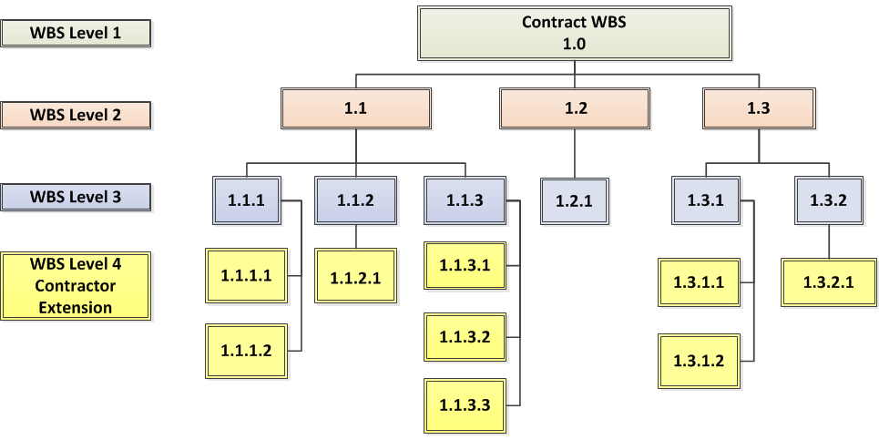

Figure B: Example Program WBS

Attributes
  - A single product-oriented WBS is used for a given contract and is extended to the level necessary for management action.
  - The WBS includes all contract work including the work scope to be performed by subcontractors and any revisions resulting from authorized changes and modifications.

Typical Work Products
- Statement of Work (SOW)
- Work Breakdown Structure (WBS)
- Traceability matrix from government requirements (i.e. Statement of Work (SOW), Build Specifications) to WBS
- WBS Index/Dictionary
- CPR/IPMR Format 1
- Base contract and modifications

Guideline 2: Define Program OBS
EVMS Category: Organization
EIA Standard Guideline: 2.1b | Define Program Organizational Breakdown Structure (OBS)
Identify the program organizational structure, including the major subcontractors, responsible for accomplishing the authorized work, and define the organizational elements in which work will be planned and controlled.
DoD Strategic Intent
Purpose of Guideline: To ensure the functional and/or program organizations responsible for accomplishing program work scope are clearly identified.

Management Value: An effective program organization, defined at the onset of the contract, enhances management control of technical schedule and cost execution. Establishing and maintaining an OBS helps management focus on establishing the most efficient organization by taking into consideration availability and capability of management and technical staff, including subcontractors, to achieve the program objectives.

Intent of Guideline: The OBS displays the organizational relationships that are responsible for assigning resources to a program. It identifies which managers in the corporate structure are responsible for accomplishing a specific scope of work consistent with the contractor’s internal organizational structure of departments, units, teams, and/or subcontractors. A well-defined OBS ensures that a specific organization, including major subcontractors, is responsible for the authorized work and helps identify the level of accountability for performing the work by taking into consideration the availability and capability of the management team and technical staff. The program manager uses a program OBS to reflect the assignment of management accountability and authority for all work supporting program objectives.

There are multiple types of program organizations that can be established: program team, project matrix organizations, Integrated Product Teams (IPTs), and functional organizations. When designating the internal organization responsible for managing the program efforts, the contractor must assign a manager with sufficient authority and responsibility to ensure performance of the authorized work. The manager assigned subcontractor work must have full responsibility for the authorized work. Figure C illustrates an example of an OBS; however, there are multiple methods of structuring an OBS.

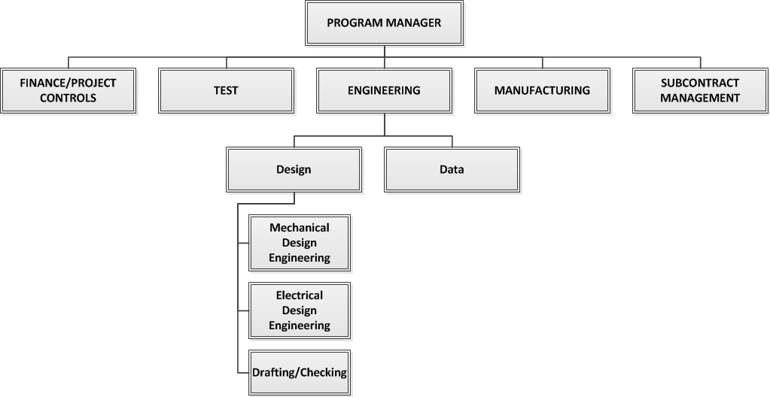

Figure C: Example Program OBS

Note: Figure is notional, there are multiple ways an organization may be structured to manage a program.

Attributes
- A single OBS exists that contains all of the organizational elements necessary to execute the contract to include major subcontracted and intra-organizational work.

Typical Work Products
- Program Organizational Chart/OBS
- Documented Roles and Responsibilities (Prime and Major Subcontractor(s))
- List of major subcontractors/intra-divisional work orders with EVMS flowdown

Guideline 3: Integrate Subsidiary Management Processes
EVMS Category: Organization
EIA Standard Guideline: 2.1c | Integrate Subsidiary Management Processes
Provide for the integration of the planning, scheduling, budgeting, work authorization and cost accumulation processes with each other, and as appropriate, the program work breakdown structure and the program organizational structure.
DoD Strategic Intent
Purpose of Guideline: To ensure the contractor establishes an interconnection between the contractor’s enterprise management systems (e.g., accounting, scheduling, estimating, procurement, Manufacturing Resource Planning (MRP), time card management systems, etc.) into an integrated framework required for effective program management.

Management Value: The integration of planning, scheduling, budgeting, work authorization, and cost accumulation management processes provides the capability for establishing the Performance Measurement Baseline (PMB), identifying work progress, and collecting actual costs, thereby facilitating management analysis and corrective actions. Having integrated management systems and common data elements helps ensure the availability of program information needed to support all levels of management insight and control.

Intent of Guideline: The integration of separate and interdependent management systems, processes and operating procedures will ensure that the data is relatable and consistent across the enterprise management systems and the EVMS. Through coding structures that use unique IDs and common data elements or a simple mapping method, the contractor’s planning, scheduling, budgeting, work authorization, and cost accumulation processes are integrated in such a way that data derived from one system is relatable to and consistent with the data of each of the other systems at both the control account level and the total contract level. MRP systems in a production environment are more widely used for planning, scheduling, dispatching/authorizing, and statusing work. Unique coding structures need to be established to interface between the material control system and the EVMS to support the transfer of data. The resulting integration of technical, cost and schedule data enables program management to effectively manage and control execution of the program work scope. The system should ensure the ability to integrate major subcontractor data.

Attributes
- The planning, scheduling, budgeting, work authorization and cost accumulation systems are integrated with each other via common coding structure and, as appropriate, with the Contract Work Breakdown Structure (CWBS) and the Organizational Breakdown Structure (OBS).

Typical Work Products
- Data item matrix describing the unique coding structure that defines the common data elements that link the management systems.
- Data-related products that relate to the unique coding structures.
  - Cost tool data
  - Integrated Master Schedule (IMS)
  - Subcontractor CPR/IMS
  - Mapping of EVMS data from subcontractor to prime

Guideline 4: Identify Overhead Management
EVMS Category: Organization
EIA Standard Guideline: 2.1d | Identify Overhead Management
Identify the organization or function responsible for controlling overhead (indirect costs).
DoD Strategic Intent
Purpose of Guideline: To ensure the program manager understands who within the contractor is responsible for establishing, approving, managing, controlling, and assigning resources to overhead (indirect costs) budgets.

Management Value: Visibility into indirect costs is essential for successful management of a program. The impact of indirect costs on any program must be accounted for and managed. It is important, therefore, to have a process documented and organizations established specifically to manage and control indirect costs. This will help ensure the program manager can effectively manage and control execution of overall program objectives.

Intent of Guideline: The contactor must clearly identify the management position assigned responsibility and authority for controlling indirect costs and that has the authority to approve the expenditure of resources. It is necessary to have an indirect budgeting and forecasting process since indirect costs account for a major portion of the cost on any program. As indirect costs can significantly impact the cost of a program, it is important for the program manager to know who is responsible for authorizing and controlling overhead (indirect) budgets and expenditures.

Attributes
- There is an indirect account organization structure in which designated managers have authority to budget and approve expenditures and control related costs.

Typical Work Products
- Organization chart identifying managers responsible for indirect cost control
- Contractor’s Cost Accounting Standards Board (CASB) Disclosure statement

Guideline 5: Integrate WBS/OBS to Create Control Accounts
EVMS Category: Organization
EIA Standard Guideline: 2.1e | Integrate WBS/OBS to Create Control Accounts
Provide for integration of the program work breakdown structure and the program organizational structure in a manner that permits cost and schedule performance measurement by elements of either or both structures as needed.
DoD Strategic Intent
Purpose of Guideline: To determine who is responsible for a specific scope of work and facilitate schedule and cost performance measurement in an EVMS. The intersection of the Work Breakdown Structure (WBS) and Organizational Breakdown Structure (OBS) establishes the control account which is the focal point for work authorization, management, and performance measurement.

Management Value: The careful establishment of the control account structure ensures the proper level of management where one organization has clear responsibility for the effort. It is established considering the complexity of the work and the efficiency of the organization. Control account is the optimal level control point in the EVMS where managerial control, performance measurement, and responsibility for corrective action should exist.

Intent of Guideline: The intersection of the WBS and the OBS, and the establishment of the control account, is necessary to understand the assigned responsibility for managing, controlling, and facilitating the allocation of resources to the work scope and permits cost accumulation and performance measurement. (See Figure D). There may be one or more responsible organizations supporting a single WBS or multiple control accounts within one OBS element. Generally, this occurs when the work within a WBS element must be segregated for management control purposes that are driven by scope and exit criteria (i.e., completion of the task). This structured approach assists the program manager with assigning responsibility and authority for performing the work scope contained in the WBS. Each control account is assigned to a control account manager (CAM). The CAM is responsible for ensuring the accomplishment of work in his or her control account and is the focal point of management control.

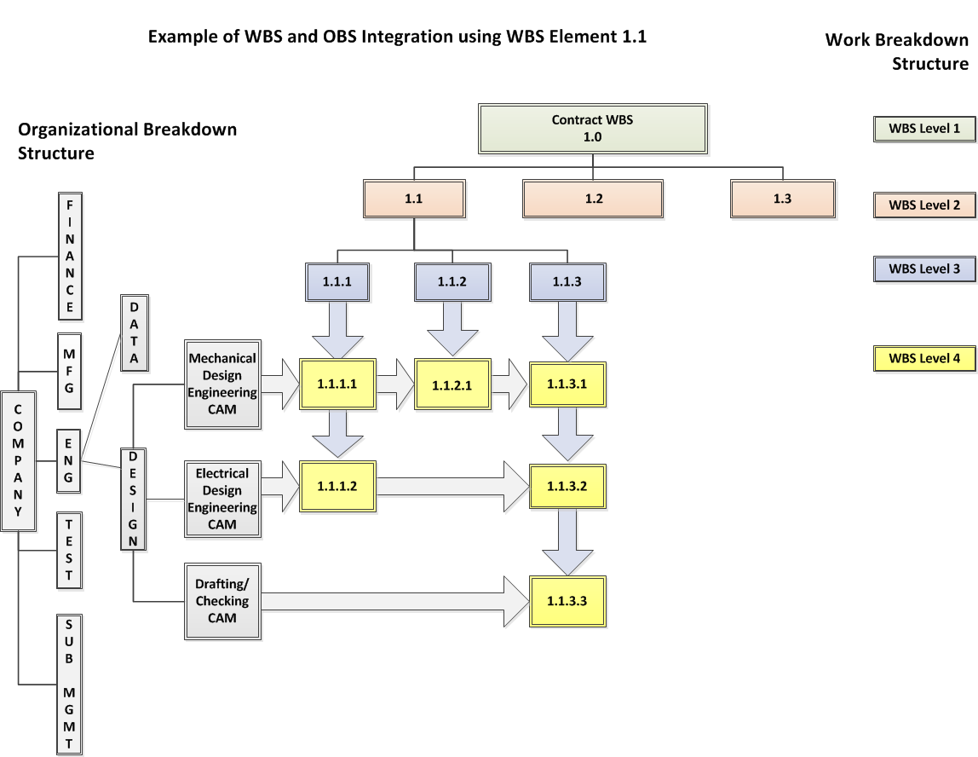
Figure D: Integration of the WBS and OBS

Attributes
- Each control account is assigned to organizational elements directly responsible for the work and identifiable to a single element of the WBS.

Typical Work Products
- Responsibility Assignment Matrix (RAM)
- Cost tool data

Planning, Scheduling, and Budgeting Category

Overview of Planning, Scheduling, and Budgeting Category and Guidelines
The focus of the Planning, Scheduling, and Budgeting category is to develop plans and strategies to achieve the desired program cost, schedule, and technical objectives. This includes the identification of short- and long-term resource needs. The ten guidelines (6 – 15) that comprise this category set the foundation for integrating scope, schedule, and cost into a baseline against which accomplishments can be measured. This baseline, called the Performance Measurement Baseline (PMB), is a dollarized time-phased plan established primarily at the control account level that reflects how the contractor intends to use its resources to accomplish all the authorized work (guidelines 8 and 9). The PMB provides the government and the contractor a common reference point for discussing program progress and success (guideline 15). As defined in DFARS 234.201 EVMS Policy, guidelines 6, 7, 8, 9, 10, and 12 are considered high risk guidelines.
Integral to establishing the PMB is the use of an integrated network schedule (guidelines 6-7). The guidelines in this category require development of an integrated network schedule that establishes and maintains a relationship between technical achievement and progress status. The schedule provides visibility into the accomplishment of the tasks required for execution of the contractual scope of work and is the basis for creating the PMB.
The guidelines further establish the planning parameters associated with the PMB including:
- establishing the Contract Budget Base (CBB), including authorized unpriced work (guideline 8),
- authorizing and partitioning control account work scope into work packages for near term effort and/or planning packages for effort outside the current planning window (guideline 10),
- using Summary Level Planning Packages (SLPP) for effort that cannot yet be detail planned at the control account level (guideline 8)
- using Undistributed Budget (UB) for contractually authorized work scope that has not yet been assigned to an organizational element at or below the WBS reporting level (guideline 14),
- ensuring inclusion of overhead budgets (guideline 13), and
- applying the most appropriate earned value measurement technique to ensure progress reported against the PMB provides reliable performance data (guidelines 10 and 12).
Allowance is made for a portion of the CBB to be withheld outside of the PMB as Management Reserve (MR) for internal management control purposes. MR is intended to provide the contractor with budget to manage risk within the established contract scope. The use of MR is to be controlled and documented (guideline 14). Lastly, the guidelines strive to maintain the integrity of the PMB by ensuring the sum of lower level budgets in the PMB does not exceed the total time-phased budget and that all internal program budgets and management reserves reconcile to the contractual target cost (guidelines 11 and 15).
Subsections 2.2.1.1 through 2.2.1.10 describe DoD’s intent and expectations for implementing each of the ten Planning, Scheduling, and Budgeting category guidelines.

Guideline 6: Scheduling Work
EVMS Category: Planning, Scheduling, and Budgeting
EIA Standard Guideline: 2.2a | Scheduling Work
Schedule the authorized work in a manner which describes the sequence of work and identifies significant task interdependencies required to meet the requirements of the program.
DoD Strategic Intent
Purpose of Guideline: To provide program management with a fully integrated, networked, time phased plan that provides visibility into the detailed progress and accomplishment of the milestones and tasks required for execution of the authorized scope of work.

Management Value: A fully-integrated schedule facilitates the establishment of a valid Performance Measurement Baseline (PMB). Scheduling authorized work facilitates effective planning, statusing, and forecasting, which are critical to the success of a program. This is accomplished through a fully networked Integrated Master Schedule (IMS), which is a foundational component in the establishment of a valid PMB. The ability to produce a critical path and driving paths allows management to evaluate and implement actions designed to ultimately complete the program effort within contractual parameters. Adequately integrating schedule data enables program management to use the schedule for time-based analyses and schedule risk assessments both of which are critical to the success of meeting program commitments. An integrated network schedule provides program management a comprehensive status of authorized work scope and facilitates the timely tracking and communication of program performance.

Intent of Guideline: A dynamic and properly functioning schedule provides program management insight into the program’s progress, planned and forecast duration, and will be the basis for projected cost to complete. The IMS is the networked schedule that establishes a logical sequence of work that leads through key milestones, events, and/or decision points to completion of program objectives. It contains all discrete, authorized work and organizational entities, including subcontractors, responsible for performing the work consistent with the Work Breakdown Structure (WBS) and the Organizational Breakdown Structure (OBS). The logical sequence of the schedule is horizontally and vertically integrated and reflects interdependencies between tasks/activities or work package and planning package level as appropriate for the work, that determines the critical path (See Figure E: Horizontal and Vertical Schedule Integration).

Production programs are often planned using inputs from manufacturing or enterprise planning systems that include the detailed efforts (Work Orders, Production Orders, Work Bills, etc.) used to manage the procurement and assembly of material with the associated labor. These systems are used as the basis for planning and statusing the detailed efforts which are aggregated, with the appropriate interdependencies and sequencing preserved, within the network schedule (IMS), minimally at the work package level, for critical path analysis. See Figure F: Relationship between IMS and Manufacturing/Enterprise Planning System.

Schedule Visibility Tasks (SVTs), if used, must be separately identified and controlled to represent non-PMB activities that could impact the logic driven network. Schedule margin is an optional management method for accommodating schedule contingencies but should not be used to offset the PMB.

Schedule progress is updated and statused in accordance with the business cycle, but no less than monthly.
- Identification and assessment of actual progress versus planned progress.
- Generation of the program critical path, near critical paths, and driving paths.
- Incorporation and progress of risk management activities and mitigation actions.
- Assessment of the maturity of the program.

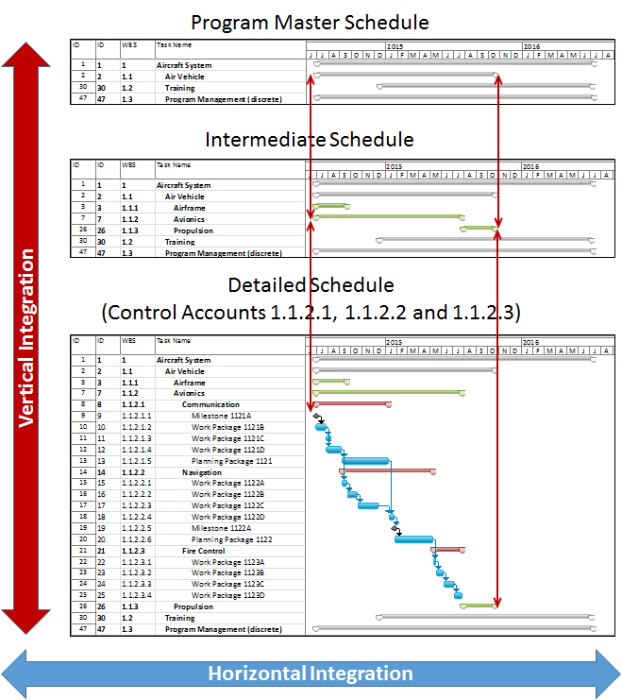
Figure E: Horizontal and Vertical Integration in the IMS

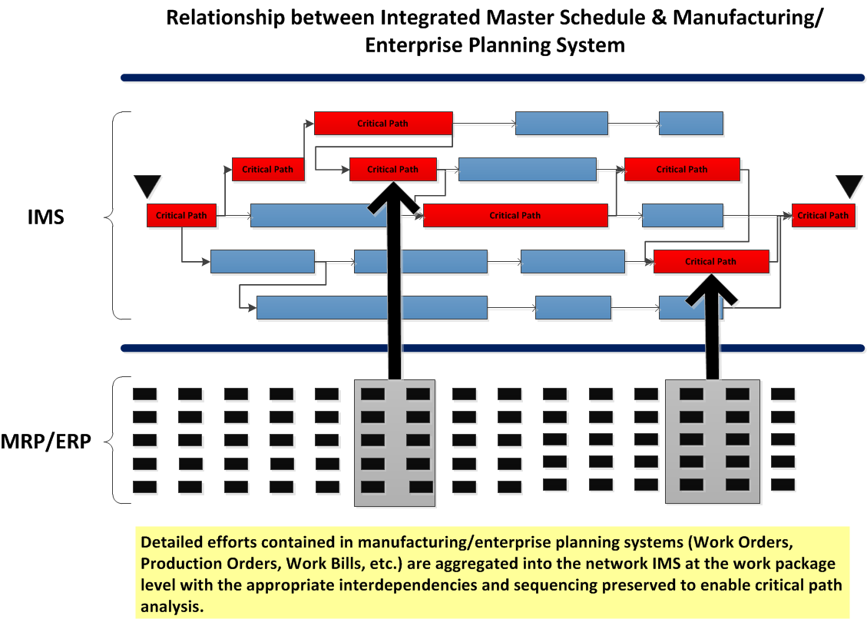
Figure F: Relationship between Integrated Master Schedule & Manufacturing/Enterprise Planning System
Attributes
- The IMS reflects all authorized, time-phased discrete work to be accomplished to include subcontracted effort and critical and/or high value material.
- The network schedule/IMS describes the sequence of work (horizontal integration) and should consider the significant interdependencies that are indicative of the actual way the work is accomplished and at the level of detail to support program critical path development.
- There is vertical schedule integration, i.e., there is consistency of data between various levels of schedules (including subcontractor schedules) and all levels of schedules support the contract/program schedule requirements.
- Program milestones, contractual events, program decision points and external dependencies must be logically linked within the network schedule/IMS.
- The schedule provides baseline, forecast, and actual dates.

Typical Work Products
- Internal schedules and/or IMS
- Risk/Opportunity Register (evidence of risk mitigation handling plan in the IMS)
- Schedule Risk Assessment
- Corrective Action Plan Summary

Guideline 7: Identify Products and Milestones for Progress Assessment
EVMS Category: Planning, Scheduling, and Budgeting
EIA Standard Guideline: 2.2b | Identify Products and Milestones for Progress Assessment
Identify physical products, milestones, technical performance goals, or other indicators that will be used to measure progress.
DoD Strategic Intent
Purpose of Guideline: To ensure program schedule(s) establish and maintain a relationship between technical achievement and progress statusing and provide objective performance data that accurately reflects the progress of the work.

Management Value: A key feature of the vertically integrated schedule network is that it establishes and maintains the relationship between technical achievement and progress statusing through time. A sufficient number of interim measures will be defined as the detailed schedule is established to ensure performance is measured as objectively as possible. Timely and accurate progress assessments lead to better management visibility into program progress and may be early indicators of program problems and/or opportunities. Identifying objective criteria, linked to technical status, will ensure the performance assessment reflects the true technical performance of the program. Early visibility results in management ability to effect timely actions to adjust program directions.

Intent of Guideline: Using objective technical acceptance criteria and performance indicators that are consistent with the work scope contained in the Work Breakdown Structure (WBS) will facilitate meaningful assessments of program accomplishment. Objective technical performance goals and measures are incorporated throughout the schedule hierarchy based on the completion criteria developed for each increment of work, in order to limit the subjectivity of the measurement of work accomplished. Objective performance data that accurately reflects technical accomplishment of the work provides program management visibility into program progress and credible, early indications of program problems and the need to take corrective action. Identifying and selecting appropriate objective completion criteria, that will align with how technical performance will be accomplished, for all discrete work and for each of the program’s key events, decision points, and milestones is essential for ensuring accurate schedule status and providing program management actionable information.

Attributes
- Objective completion criteria aligned with accomplishment of the program’s technical requirements and goals are determined in advance, documented, and used to plan and measure the progress of program milestones and events against the passage of time.
Typical Work Products
- Integrated Master Schedule (IMS)
- Integrated Master Plan (IMP), if required
- Contract and modifications

Guideline 8: Establish the Performance Measurement Baseline
EVMS Category: Planning, Scheduling, and Budgeting
EIA Standard Guideline: 2.2c | Establish the Performance Measurement Baseline
Establish and maintain a time-phased budget baseline, at the control account level, against which program performance can be measured. Initial budgets established for performance measurement will be based on either internal management goals or the external customer negotiated target cost including estimates for authorized but undefinitized work. Budget for far-term efforts may be held in higher level accounts until an appropriate time for allocation at the control account level. If an over-target baseline is used for performance measurement reporting purposes; prior notification must be provided to the customer.
DoD Strategic Intent
Purpose of Guideline: To create a time-phased, resourced plan against which the accomplishment of authorized work can be measured. This plan includes budget provisions for potential program risk and must ensure resources for accomplishing the work are time-phased consistent with the planned work scope for all of the authorized work. This time-phased relationship between authorized work, time, and resources is referred to as the Performance Measurement Baseline (PMB). When the value of the baseline plan is projected to exceed agreed-to values for the authorized work, the customer must be notified in advance. (See Guideline 31).

Management Value: The government and the contractor have a common reference point, the PMB, for discussing program progress and success. The accurate reporting of progress against a mutually recognized plan facilitates the implementation of actions by management to keep or put the program back on schedule or cost. The establishment of realistic budgets, directly tied to the authorized scope of work, is essential for each organization responsible for performing program effort. Also, the establishment and use of the PMB are indispensable to effective performance measurement and it should be in place as early as possible after contract award or Authorization to Proceed (ATP).

Intent of Guideline: The PMB is what actual performance is compared against to assess progress to plan. The Contract Budget Base (CBB) value used to establish the PMB is tied to the current value of the contract, including any authorized, unpriced work (see Figure G: Initial Baseline Planning). The PMB is established, at a minimum, at the control account level. For future effort that cannot practically be identified to a control account, it is permissible to establish a summary level planning package (SLPP) above the control account level that identifies scope, schedule, and associated budget to the end of the contract (see Figure H: Time Phasing the PMB). These summary efforts should be subdivided into control accounts at the earliest opportunity. Planning horizons may be used to determine the appropriate time period in which to convert SLPPs into control accounts (see Guideline 29 for further details). The budget for this effort must be identified specifically to the work for which it is intended, time-phased, periodically reviewed for validity, and not be used to perform other scopes of work. Eventually, all the work will be planned by specific organizational elements to the control account. Budget tied to authorized scope but not readily identifiable to a specific control account or SLPP can be temporarily placed in Undistributed Budget (UB) (see Guideline 14 for further details). Budget not directly tied to authorized scope is set aside as Management Reserve (MR) and is not included in the PMB (see Guideline 14 for further details). The contractor ensures that the resource plan is executable within budget and schedule constraints and is realistic to achieve the contract scope. On production efforts, contractors should be able to demonstrate that the initial budget distribution at the control account level is consistent with need-by dates and the resources loaded in the MRP/ERP systems.

There may be situations when the existing baseline may not represent the actual plan forward due to contract changes, over or under performance, etc. In these cases, it may become necessary for the total budget allocated to the work to exceed the CBB, a condition known as an Over Target Baseline (OTB), and/or for the baseline schedule to exceed contract milestones, a condition known as an Over Target Schedule (OTS). Advance notification to and approval from the customer is essential prior to the implementation of an OTB or OTS. See Guideline 31.

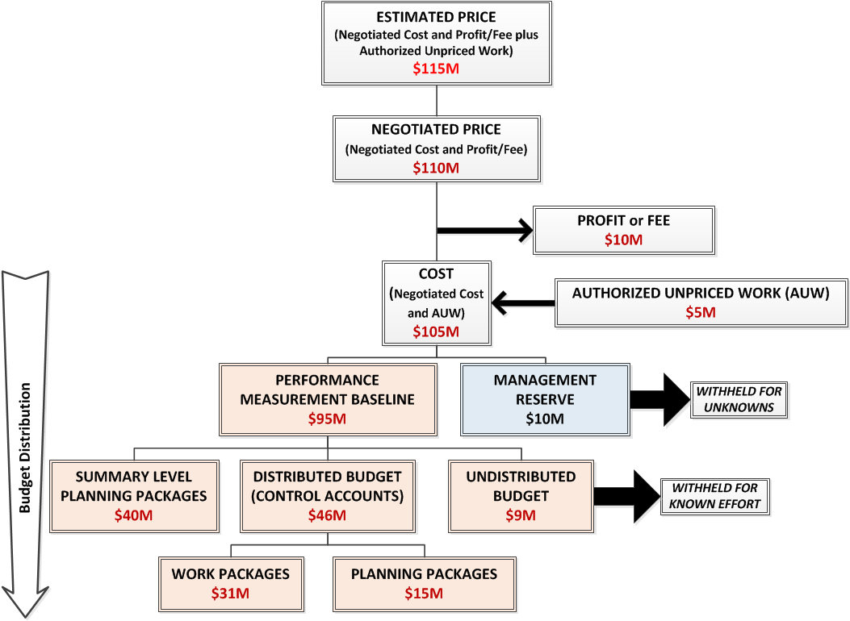

Figure G: Initial Baseline Planning

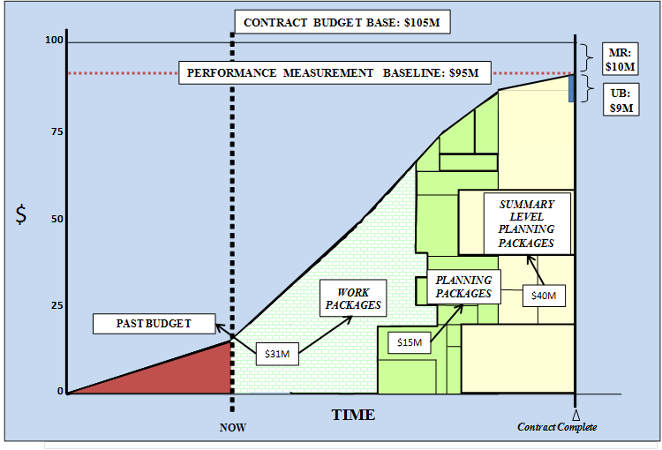
Figure H: Time Phasing the PMB

Attributes
- The PMB is time-phased in alignment with the IMS, with budget distributed in accordance with the accounting calendar for the authorized work scope including all CA and SLPP.
- The time-phased budget baseline reflects the resources planned to perform the authorized work scope and only exceeds the CBB with prior customer authorization of an OTB.

Typical Work Products
- Control account plans
- Integrated Master Schedule (IMS)
- Budget log reflecting base contract plus all modifications
- Cost tool data
- CPR/IPMR Formats 1, 2, and 3
- Basis and Customer approval for OTB (as applicable)
- Fiscal/accounting calendar

Guideline 9: Authorize and Budget by Cost Elements
EVMS Category: Planning, Scheduling, and Budgeting
EIA Standard Guideline: 2.2d | Authorize and Budget by Cost Elements
Establish budgets for authorized work with identification of significant cost elements (labor, material, etc.) as needed for internal management and for control of subcontractors.
DoD Strategic Intent
Purpose of the Guideline: To ensure each control account has identified and budgeted the resources required to complete the authorized work.

Management Value: The ability to allocate resources effectively, to subcontract as necessary, and to ensure that all required resources are committed and available to the program is enhanced by segregating resource type at the control account or work package level. Ensuring control account budgets are assigned to and planned by elements of cost facilitates management insight into program performance at the resource level. This enables the contractor to more effectively manage and control execution of the control account work scope within schedule and budget constraints.

Intent of Guideline: No work shall begin before work is authorized by an initial work authorization. Formally authorizing the work ensures the assignment of program work scope to the responsible organization is clearly documented and that the resources required for completing the work are budgeted and acknowledged by the management team prior to commencement of work. All resources required to accomplish the work scope are included throughout the Work Breakdown Structure (WBS). Budget is set aside for work scope which is further planned by the elements of cost for labor, material, subcontractor, and other direct charges required to accomplish it. Through a formal work authorization process, the elements of cost required to execute the control account’s scope of work are identified, planned, and documented. Approved work authorization must precede the baseline start and actual start of work.

Budgets are established by element of cost: direct labor, subcontractor, material, and other direct costs. See Guideline 13 for establishing indirect budgets. Budgets may be stated in dollars, hours, or other measurable units consistent with the budget values reflected in the control account plans and the latest work authorization documentation. It is necessary to use current direct rates to establish a valid performance measurement baseline (PMB). Control account budgets are time-phased consistent with the program schedule; material budgets are time-phased as appropriate (see Guideline 21); and subcontractor budgets are time-phased to support program schedule requirements. Material budgets should be based on the defined/expected quantities needed to meet the requirement (Bill of Material is typically the basis of the budgets). Budget for authorized subcontractor work is based initially on the prime contractor’s estimated value and must be updated to reflect negotiations. Authorized subcontracted work must be integrated into the prime contractor’s PMB. See Figure I: Notional Work Authorization and Control Account EOC Relationship.

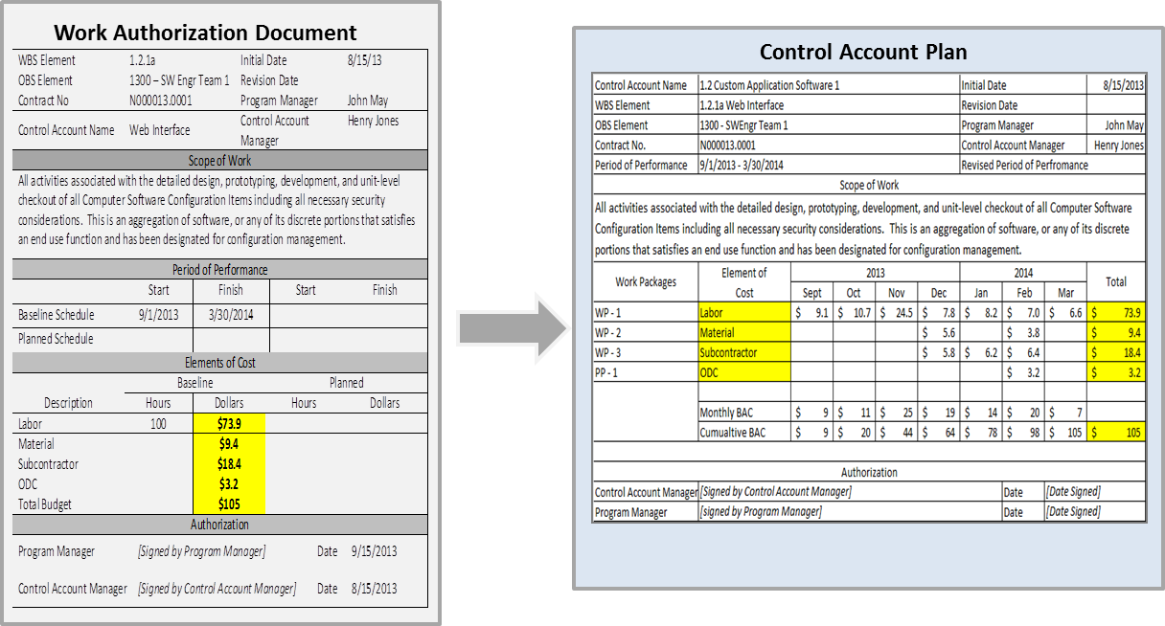

Figure I: Notional Work Authorization and Control Account EOC Relationship
Note: Work authorization is a process that results in documentation. Figure is not intended to imply a single document authorizing work is required such as a “work authorization document”. Documentation requirement may be met in multiple ways.

Attributes
- Work authorization dates are consistent with control account dates (actual and baseline).
- Within control account plans, budgets are segregated and identified by element of cost (i.e., direct labor category, direct labor dollars/hours, material and/or subcontract dollars, and other direct costs).

Typical Work Products
- Work authorization documentation
- Control account plans
- Integrated Master Schedule (IMS)
- Cost tool data

Guideline 10: Determine Discrete Work and Objective Measures
EVMS Category: Planning, Scheduling, and Budgeting
EIA Standard Guideline: 2.2e | Determine Discrete Work and Objective Measures
To the extent it is practicable to identify the authorized work in discrete work packages, establish budgets for this work in terms of dollars, hours, or other measurable units. Where the entire control account is not subdivided into work packages, identify the far term effort in larger planning packages for budget and scheduling purposes.

DoD Strategic Intent
Purpose of Guideline: To ensure that control account work scope is partitioned into executable and measurable segments of work that can be accomplished over the contractual period of performance.

Management Value: Work packages and planning packages contain authorized scope and budgets that include specific resource requirements in dollars, hours, or other measurable units. Additionally, the development of earned value techniques will allow for accurate and objective performance measurement. This provides program management accurate status and situational awareness of program execution.

Intent of Guideline: The control account is the central management control point and is where program cost, schedule and work scope requirements are integrated and managed. Control accounts are decomposed into work packages and planning packages. In order for the program manager to effectively manage execution of the program within budget and schedule constraints, discrete work packages must be established and objectively measured. Work packages are a clearly distinguishable subdivision of control accounts assignable to a single organizational element and are where the work is planned, progress is measured, and earned value is determined. Work package and planning package quantities, sizes and durations within a control account will vary subject to scope, internal management needs, and the size and complexity of the contract. Planning the work in small, manageable segments of work provides for more accurate performance status as task execution is measured at the working level. Distributing all control account budgets to either work packages or planning packages ensures the performance measurement baseline (PMB) will be planned at an executable level and that meaningful performance measurements will be obtained. A control account manager shall not have a budget without an assigned scope of work. Conversely a control account manager shall not have authorized scope without associated budget. This shall result in no zero budget work packages or planning packages.

Work packages have the following characteristics:
- Represents the scope of work at the level where work is performed
- Clearly distinguished from all other work packages
- Assigned to a single organizational element.
- Scheduled start and completion dates and as applicable, interim milestones, all of which are representative of physical accomplishment.
- Has a budget or assigned value expressed in terms of dollars, labor hours, or other measurable units that is substantiated in terms of supporting project plans
- Duration is limited to a relatively short span of time that is practical for the work scope. Longer tasks need objective interim measures, such as points of technical achievement, to enable accurate performance assessment.
- Integrated with detailed engineering, manufacturing, or other schedules.

Other work package planning requirements include:
- Material is segregated from other elements of cost, planned in support of the need dates for the material items, and time-phased by dollar amount to the period in time suitable for the type of material category. Establishment of earned value techniques (EVTs) for material shall be consistent with the manner in which material is planned. For further information on a range of points for material performance, see Guideline 21.
- Subcontract effort identified (as applicable) and is time-phased consistent with subcontractor program plans. Subcontractor and contractor plans are directly reconcilable.

Each work package on the project needs to be established using the best method to budget and then measure its progress toward completion. Based on the nature of the work contained in work packages, they are classified as discrete, apportioned, or Level of Effort (LOE) and an appropriate earned value technique is identified for use in measuring work accomplishment. Discrete work is defined as a specific product or service with distinct and measurable outputs that are relatable to the program’s technical objectives. These measureable outputs are where program status can be measured objectively. Examples of measureable products or outputs include design efforts, a tool design package, a build-to-package, a shop order, a part number, a purchase order, or any other definable product. Where long-duration work packages are unavoidable, interim milestones representing measurable, technical accomplishment are required for performance measurement. Every attempt should be made by the contractor to identify and plan the authorized work within a control account using discrete, short-spanned work packages comprising all the measurable efforts.

The concept of "apportioned effort" work packages should be used when work of a supporting nature that ties directly to a discrete technical activity. Apportioned effort is work that is not readily measured or divisible into discretely planned work packages but is directly proportional to the planning and performance of other discretely planned work; e.g., quality assurance and other inspection functions may be treated as apportioned effort based on the amount of manufactured items. The EVMS must cover the requirements for the use of this measurement technique and the need to document the factor used to establish the relationship; i.e., a direct, historical relationship between the base effort and the apportioned effort. It must also point out that the progress identified in the base account (percent complete) provides the progress percentage for the apportioned account.

LOE is defined as being of a general or supportive nature, with no measurable output, product, or activities, for which the attempt to measure progress would be not value-added. Work packages for LOE have budgets and work scope with a sound Basis of Estimate (BOE) and are time-phased to properly reflect when the work will be accomplished. LOE should be separately identified from discrete effort and apportioned effort work packages. (See Guideline 12 for additional information on LOE.)

In general, budgets for all material, to include high value production material, should be planned discretely using objective milestones or other rational basis for measuring the amount of material consumed. An analysis needs to be conducted to identify and differentiate between high value, critical material from low value, consumable-type material. See Guideline 21 for further information on material EVTs.

When authorized work scope cannot be planned in the near term, a planning package is used for holding the scope, schedule, and budget until the work can be detail planned into work packages. The planning package is time-phased with the known schedule requirements and is decomposed into work package(s) at the earliest practicable point and prior to any work being performed on the scope contained in the planning package. For subcontracted efforts, the prime contractor is responsible for ensuring subcontract work scope and associated budget are consistent with the subcontractor program plan and that subcontractor and prime contractor plans are reconcilable. As near term work will be more detailed than that of the work scope contained in planning packages, there is a periodic detail planning process in place to convert SLPP into control accounts and control account planning packages into work packages (or lower level tasks/activities). In order to solidify the PMB for accurate performance measurement, it is necessary to establish a freeze period. During the freeze period, changes to the PMB are limited to maintain its integrity. (See Guideline 29 for more information on rolling wave process and freeze period.)

Attributes
- Realistic segments of authorized work.
- Identification of objective indicators of physical or technical progress supporting accurate in-process measurement.
- Fully-integrated work packages supporting intra- and inter- control account relationships.
- Detail planning based on the most current work definition.
- Planning packages with the relationship between scope, schedule, and resources defined.
- Work packages are comprised of detailed job activities, and/or material items. They are units of work/material at levels where work is performed and are clearly distinguishable from all other work packages.
- A planning package is the logical aggregation of work within a control account, normally the far-term effort, that can be identified and budgeted in early baseline planning, but cannot yet be defined into work packages planned as discrete, apportioned, or level of effort. Planning packages must reflect the time periods in which the work is expected to be performed by the responsible organizational element.
Typical Work Products
- Control account plans
- Objective plan for substantiating the value of work claimed as progress
- Integrated Master Schedule (IMS)
- Cost tool data

Guideline 11: Sum WP/PP Budgets to Control Account
EVMS Category: Planning, Scheduling, and Budgeting
EIA Standard Guideline: 2.2f | Sum Work Package (WP) and Planning Package (PP) Budgets to the Control Account
Provide that the sum of all work package budgets plus planning package budgets within a control account equals the control account budget.
DoD Strategic Intent
Purpose of Guideline: To maintain the integrity of the performance measurement baseline (PMB), the budgets of the work packages and planning packages shall sum to the associated control account’s budget at completion (BAC).

Management Value: The value assigned to the control account (scope, schedule, resources/budgets) is the value that is time-phased into work packages and planning packages. Failure to do this results in a program plan that does not correlate to the contract requirements and, therefore, does not provide a common reference point for government-contractor discussions and for accurate progress assessments. It may also result in over or under allocation of program budgets.

Intent of Guideline: It is important to the overall integrity of the PMB that control account budgets are planned and summarized accurately. The control account is the management control point at which the program manager will analyze program performance by comparing actual performance to the planned budgets. All control accounts contain the budget that realistically represents the work scope assigned to the performing organization. The value of the budgets assigned to individual work packages and planning packages within the control account will sum to the total budget authorized in that control account.

Attributes
- The sum of all work package budgets plus planning package budgets within control accounts equals the budgets assigned to those control accounts.

Typical Work Products
- Control account plans
- Cost tool data

Guideline 12: Level of Effort Planning and Control
EVMS Category: Planning, Scheduling, and Budgeting
EIA Standard Guideline: 2.2g | Level of Effort Planning and Control
Identify and control level of effort activity by time-phased budgets established for this purpose. Only that effort which is not measurable or for which measurement is impracticable may be classified as level of effort.
DoD Strategic Intent
Purpose of Guideline: To ensure Level of effort (LOE) is limited only to those activities that should not or cannot be discretely planned. Classification of work scope as LOE is limited to activities that have no measurable output or product associated with technical effort that can be discretely planned and objectively measured at the work package level.

Management Value: Prudent use of LOE is necessary to minimize the distortion of performance data for effective program management. The need to look at each effort on the program and determine if there is a way to measure progress towards its completion leads to a Performance Measurement Baseline (PMB) that provides more accurate information to management for program decision making. In every program, there are tasks that must be accomplished that, by their nature, are unmeasureable.

Intent of Guideline: A fundamental expectation of an Earned Value Management System (EVMS) is that objective and actionable information on program status will be generated and used as the basis for making logical, well-informed program management decisions. Unlike discrete and apportioned work, LOE work is defined as having no measurable output or product that can be discretely planned and objectively measured at the work package level. The nature of LOE is such that there is never a Schedule Variance (SV); i.e., BCWP always equals BCWS. Therefore, LOE is limited only to those activities that are unable or impracticable to be measured discretely to in order to ensure that the resulting overall progress assessment will be more accurate. LOE activities are typically administrative or supportive in nature and may include work in areas such as program management, contract administration, financial management, security, field support, help desk support, or clerical support. Work packages shall be separately identified as either LOE, discrete, or apportioned (see Guideline 10) to facilitate accurate insight into performance and variance status. The incorrect application of LOE causes misrepresentation of performance status. Care must be taken to ensure that when work packages planned as discrete or LOE are commingled within a control account, the contractor must identify proper controls to limit the amount of LOE and the potential for distortion of performance and variance analysis.

Attributes
- Contain tasks of a general or supportive nature that do not produce technical content leading to an end item or product.
- Must be separately evaluated from discrete and apportioned work packages within the control account.

Typical Work Products
- Control account plans
- Work authorization documentation
- Integrated Master Schedule (IMS)
- Work Breakdown Structure Index & Dictionary
- Cost tool data
- Government requirements document (i.e. Statement of Work (SOW), Build Specifications)

Guideline 13: Establish Overhead Budgets
EVMS Category: Planning, Scheduling, and Budgeting
EIA Standard Guideline: 2.2h | Establish Overhead Budgets
Establish overhead budgets for each significant organizational component of the company for expenses that will become indirect costs. Reflect in the program budgets, at the appropriate level, the amounts in overhead pools that are planned to be allocated to the program as indirect costs.
DoD Strategic Intent
Purpose of Guideline: To ensure overhead budgets are established and included in the Performance Measurement Baseline (PMB) at the appropriate level for visibility.

Management Value: The overall value of establishing indirect budgets lies in the ability of contractor management to manage costs that cannot be directly assigned to individual cost objectives. By comparing actual indirect expenses to established indirect budgets, the contractor can determine if the absorption of indirect expenses based on existing documented allocation schemes is on track or if allocation rates will need to be adjusted. It is critical to the contractor that, at the end of the accounting year, all indirect expenses be allocated. The accurate assignment of indirect budgets, therefore, ensures that each program will be allocated only its fair share of indirect costs.

Intent of Guideline: Program indirect (overhead) costs are for common activities that cannot be identified specifically with a particular program or activity and will be budgeted and controlled separately at the functional or organizational manager level. Indirect budgets play an important role in budgetary control and management and can account for a major portion of the cost of any program. The overall value of establishing indirect budgets lies with the ability of the contractor to manage cost elements that cannot be directly assigned to individual programs or program tasks and ensuring that indirect costs allocated to programs are applied fairly and appropriately. Without this budgeting requirement, no baseline can be constructed that would accurately measure contractor performance/progress.

Establish indirect (overhead and General & Administrative (G&A) expense) budgets at the appropriate organizational level for each pool and cost sub-element. Program-specific budgets for indirect costs (e.g., overhead and G&A expense) are developed and planned in conjunction with the direct budgets and must be consistent with the contractor’s documented procedures for how indirect costs are approved and allocated to the program (Figure J: Example of Application of Indirect Rates to Direct Costs).

Figure J: Example of Application of Indirect Rates to Direct Costs
Attributes
- Indirect budgets (i.e., overhead and G&A expense, Cost of Money (COM)) are established and projected, annually at a minimum, based on published rates for each organization which has authority to incur overhead costs.
- Indirect budgets are incorporated into the PMB in concert with described processes and approved rates.

Typical Work Products
- Contractor’s Cost Accounting Standards Board (CASB) Disclosure Statement
- Forward Pricing Rate Agreement and/or Forward Pricing Rate Proposal
- Indirect cost policies and procedures
- Internal program reports with indirect budgets
- Cost tool data
- CPR/IPMR

Guideline 14: Identify MR and UB
EVMS Category: Planning, Scheduling, and Budgeting
EIA Standard Guideline: 2.2i | Identify Management Reserves (MR) and Undistributed Budget (UB)
Identify management reserves and undistributed budget.
DoD Strategic Intent
Purpose of Guideline: To ensure the budgets established for Management Reserve (MR) and Undistributed Budget (UB) are separately identified, controlled, and properly used.

Management Value: The ability to establish an MR budget allows program management to react to unforeseen in-scope situations that arise during the life of a program. The use of MR to account for these situations allows the Control Account Managers (CAMs) to manage to a budget that is realistic and reflective of the current plan. MR provides a means for handling program risk and in-scope unanticipated events. MR is not a source of funding for additional work scope or the elimination of performance variances.

UB is budget that is applicable to specific contractual effort(s) that have not yet been identified to Work Breakdown Structure (WBS) elements or control accounts. UB may also contain scope subject to removal from the distributed baseline due to contractual changes. UB accommodates contract situations where authorized scope and budget cannot yet be allocated to the Performance Measurement Baseline (PMB) at or below the WBS reporting level. UB is a transitional budget that should be distributed in a timely manner.

Intent of Guideline: MR and UB serve distinctly different purposes. It is important they are separately identified and traceable through the EVMS.

MR belongs to the contractor Program Manager, not the Government, and provides the contractor with a contingency budget for unplanned activities within the current program scope such as unexpected work that is in scope to the contract or rate changes. MR enables program management to respond to future unforeseen events within the work scope of the program by distributing budget held for potential program risks. To establish MR, program management sets aside a portion of the budget based on the program’s risk management process and assessment. MR budget is not associated with a specific scope of work and is not included in the PMB. The MR is always reported as a positive value and is set aside for program risks or unplanned events that may become necessary within the contractually authorized work scope such as scope growth within the contract statement of work, rate changes, unrealized risks and opportunities, and other program unknowns. Program management cannot use the MR budget: to offset overruns/harvest underruns, as a contingency that can be eliminated from prices during subsequent negotiations, or to absorb the negotiation loss resulting from definitization of a supplemental agreement.

UB is budget associated with a scope of work that has not yet been assigned to a control account or Summary Level Planning Package (SLPP). Identification of the program’s UB, along with how, when, and where it is distributed into the PMB, ensures program management is able to account for and report on all authorized budget. The UB is associated with contractually authorized work scope that has not yet been assigned to an organizational element at or below the WBS reporting level. UB is used for authorized work scope and thus, in spite of the fact that it is not time-phased, it is included in the PMB for reporting purposes. Authorized Unpriced Work (AUW), newly definitized work scope where timing of a contract change prevents the incorporation of the work at a lower level of the PMB during the current reporting period, work placed under a “stop work”, and work that has been de-scoped but not yet contractually removed from the program is placed in UB. UB is a short-term holding account where the budget is expected to be distributed into the PMB or removed from the contract. Delays in contract direction may impact the timely assignment of UB into control accounts and/or work packages. Controlling of changes to the PMB related to MR allocation(s) and UB distribution(s) are addressed under Guidelines 28, 29, and 32. For more information on circumstances when UB remains undistributed over a sustained period of time see Guideline 28..

Attributes
- MR budget has no scope defined and is separately identified outside of PMB.
- UB has defined scope, is separately identified, traceable to contractual actions and is part of the PMB.

Typical Work Products
- Program budget control logs
- CPR/IPMR Format 1

Guideline 15: Reconcile to Target Costs
EVMS Category: Planning, Scheduling, and Budgeting
EIA Standard Guideline: 2.2j | Reconcile to Target Costs
Provide that the program target cost goal is reconciled with the sum of all internal program budgets and management reserves.
DoD Strategic Intent
Purpose of Guideline: The program’s negotiated contractual target cost plus Authorized Unpriced Work (AUW) must reconcile with the Total Allocated Budget (TAB).

Management Value: This guideline ensures that the target cost value is traceable to the sum of the internal budgets and management reserve. By doing so, a common point of reference is established that is fully understood by all parties and supports both performance assessments and funding requirements.

Intent of Guideline: Reconciling the sum of all internal program budgets (control account budgets, Summary Level Planning Packages (SLPPs), and Undistributed Budget (UB)) and Management Reserves (MR) to the contractual target cost establishes the basis for managing the program. It is essential for program management to account for all budget authorized for the contractual scope of work. This is demonstrated by reconciling the negotiated contract cost (NCC) plus the estimated value of any un-negotiated unpriced-change-orders received to date to the Contract Budget Base (CBB) and to the Performance Measurement Baseline (PMB) plus MR to ensure there is consistency. All control account budgets, SLPPs, and UB are summed up to a total value known as the Budget at Completion (BAC) of the PMB. Having validated the sum of the internal budgets, this sum plus MR equals the value known as the CBB. The CBB also equals the TAB unless there is a recognized Over-Target Baseline (OTB). In that case, the TAB must be reconciled to the CBB and any recognized OTB. (See Guideline 31 for more information.) See Figure K: Budget Hierarchy and Summarization.

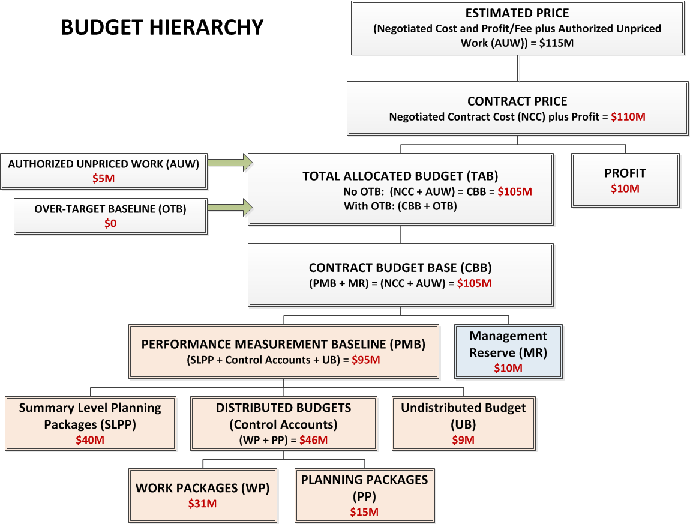

Figure K: Budget Hierarchy and Summarization
Attributes
- The sum of the control account budgets, SLPP budgets, UB, and MR reconcile with the contract target cost plus the estimated cost of AUW and recognized OTB.

Typical Work Products
- Contract and Modifications
- Program budget control logs
- CPR / IPMR
- Cost tool data

Accounting Considerations Category

Overview of Accounting Considerations Category and Guidelines

The Accounting Considerations category focuses on ensuring that all direct and indirect costs associated with accomplishing the complete scope of work contained in the contract are properly transferred to the EVMS at the level of detail required for performance analysis and reconcilable to contract performance reports. All financial transactions are expected to be documented, approved, and recorded properly in the financial accounting system on a consistent and timely basis in accordance with Generally Accepted Accounting Principles (GAAP) and applicable Cost Accounting Standards (CAS). As the EVMS uses actual cost data from the contractor’s accounting system to accurately report program costs and to conduct EVM performance and variance analysis, the accounting system is critical to ensuring EVM performance data is reliable and auditable. However, EVMS compliance does not extend to assessing the validity of the corporate accounting system. The primary objective of the six guidelines (16 – 21) that comprise this category is to ensure cost data is accurately summarized and processed between the accounting system and the EVMS within accepted accounting practices. As defined in DFARS 234.201 EVMS Policy, guidelines 16 and 21 are high-risk guidelines.
The guidelines require the EVMS to use the actual costs that are recorded in a formal and accepted accounting system that is under general ledger control and operating in accordance with the accounting practices prescribed by the CAS Board (CASB). To ensure actual direct costs are accumulated and assigned to control accounts consistent with planned budgets and acceptable costing techniques, the contractor’s CASB Disclosure Statement requires that only the direct costs actually expended to complete a specific budgeted scope of work may be accumulated or charged to that scope of work (guideline 16). All indirect costs allocable to a program must be properly recorded and correctly allocated (guideline 19).
Acceptable points for measuring material performance are specified and material costs are required to be reported in the same accounting period that performance is claimed. In the event actual costs for work accomplished have not yet been formally recorded in the accounting system, estimated actuals are used for EVM performance reporting and assessment thereby ensuring that any cost variances accurately represent the cost status of the work accomplished (guideline 21). The actual cost of work performed reported in the EVMS must be reconcilable with the actual costs contained in the accounting system (guidelines 16 and 21).
The Accounting Considerations guidelines also require actual costs to be accurately accumulated and summarized within the EVMS by the program’s Work Breakdown Structure (WBS) and Organizational Breakdown Structure (OBS) elements (guidelines 17 and 18). Records showing full accountability for all material purchased for the contract, including residual inventory must be maintained and, as applicable, the accounting system must be able to identify unit costs, equivalent unit costs, or lot costs and distinguish between recurring and non-recurring costs (guidelines 20 and 21). Identifying unit costs is used for cost estimating purposes and is typically applicable to production contracts.

In addition, DoD solicitations and contracts contain DFARS provision 252.242-7006, Accounting System Administration, which requires the contractor’s accounting system to provide for the accumulation of costs under general ledger control and accounting practices promulgated by the Cost Accounting Standards Board (CASB), if applicable, otherwise, Generally Accepted Accounting Principles (GAAP). The contractor needs to ensure a timely and accurate transfer of actual cost information from the accounting system into the EVMS. Contractors must demonstrate that the actual costs reported in the EVM performance reports reconcile to the costs recorded in the general books of account (accounting system). The contractor’s EVM SD must describe how estimated costs for work accomplished during a reporting period are recorded in the EVMS and how these estimates are reconciled in the accounting system.
Subsections 2.3.1.1 through 2.3.1.6 describe DoD’s intent and expectations for implementing each of the six Accounting Considerations category guidelines.

Guideline 16: Record Direct Costs
EVMS Category: Accounting Considerations
EIA Standard Guideline: 2.3a | Record Direct Costs
Record direct costs in a manner consistent with the budgets in a formal system controlled by the general books of account.
DoD Strategic Intent
Purpose of Guideline: To ensure that the actual direct costs expended to accomplish a specific, budgeted scope of work are appropriately collected, charged, and reconciled with the corresponding actual direct costs from the accounting system.

Management Value: To support program management, direct costs must be assigned to a program consistent with the corresponding budgets in order to achieve effective performance management and Estimate at Completes (EAC).

Intent of Guideline: Accumulating direct costs consistent with how the related work was planned and budgeted facilitates comparison of actual direct costs to work budgets for EVM performance and variance analysis. The proper collection and allocation of direct costs to associated budgeted work performed ensures that any cost variances generated when assessing performance accurately represent the cost status of the work accomplished. The contractor’s accounting system provides for accumulation of all actual direct costs (e.g. labor, subcontractor, material, other direct costs) incurred in accomplishing the authorized work scope. To ensure those actual costs are directly compared with the associated work budgets for performance measurement, the direct cost-charging structure established in the contractors accounting system should reconcile to the control accounts at a minimum. Subcontractor costs also must be accrued in a timely manner. This may require the use of estimated costs (estimated actuals) and/or the equivalent import from the subcontractor’s general accounting ledger. At a minimum, actual costs are collected at the control account level to allow for summarization of cost by either the Work Breakdown Structure (WBS) or the Organizational Breakdown Structure (OBS). The actual costs reported in the performance reports must reconcile with costs recorded in the formal accounting system.

In the event actual costs for subcontractor and/or material have not yet been formally recorded in the accounting system, estimated costs (estimated actuals) will be used for earned value management performance reporting and assessment in the EVMS. This is used to address timing differences between the accounting system and performance reports but also must be reconcilable using estimated actuals, when needed. Once actual costs have been recorded, they will replace the estimated costs (estimated actuals) recorded in the EVMS. Material actual cost accumulation is further addressed in guideline 21. All estimated costs (estimated actuals) used for performance reporting will be reconcilable to the accounting system general ledger.

Attributes
- The actual cost of work performed (ACWP) in the EVMS is reconcilable with the actual costs in the accounting system.
- Actual costs must be recorded on the same basis in which budgets were assigned (BCWS) at the control account level at a minimum.
- The EVMS will use estimated costs (estimated actuals) to account for the costs of work accomplished that have not yet had actual costs recorded in the accounting system.
- Contractor's CAS board disclosure statement identifies treatment of direct costs (direct material, labor, and other direct costs) and credits.
- Contractor ensures actual costs and performance are recorded in the same accounting period (a further explanation of recording of costs for material is provided in GL21).
Typical Work Products
- Contractor’s Cost Accounting Standards Board (CASB) Disclosure statement
- Internal Cost Reports reflecting reconciliation of control account actual costs with the general ledger
- Control Account Plan reflecting BCWS, BCWP, and ACWP
- WBS/Cost Collection Mapping
- Cost tool data
- General accounting ledger
- Work authorization documentation
- Internal control policy and procedures

Guideline 17: Summarize Direct Costs by WBS Elements
EVMS Category: Accounting Considerations
EVMS Standard Guideline(s): 2.3b | Summarize Direct Costs by WBS Elements
When a work breakdown structure is used, summarize direct costs from control accounts into the work breakdown structure without allocation of a single control account to two or more work breakdown structure elements.
DoD Strategic Intent
Purpose of Guideline: To ensure the costs reported and analyzed at higher levels of the Work Breakdown Structure (WBS) only reflect the costs associated with accomplishing the WBS scope of work.

Management Value: Accurate cost summarization by WBS element is to provide management, both internal and external, with visibility into the current cost of products and services being procured under the contract. Understanding that actual costs are being accurately accumulated and summarized supports effective analysis of performance measurement information and forecasting of potential future costs.

Intent of Guideline: Actual costs are collected, at a minimum, at the control account level and summarized to successively higher WBS levels for reporting and performance measurement purposes. To prevent distorting data and related assessments of performance, internal controls are in place to ensure that direct costs collected within control accounts are accurately summarized up through the WBS without being allocated to two or more higher level WBS elements. The charge number structure uniquely relates actual costs to control accounts and facilitates the summarization of costs by the WBS. When combined with a WBS where lower-level WBS elements roll-up to a single higher-level WBS element this assures direct costs will be summarized and reported only within a single WBS element. Assurance that accurate cost data is being reported throughout the various levels of the WBS provides program management with the confidence that the data is reliable. Validity of the resulting performance metrics enhances management’s ability to make programmatic decisions and properly forecast future costs for the remaining work.

Attributes
- Direct cost shall summarize from the lowest defined level through the WBS hierarchy (including control accounts and work packages).
- Direct costs for a control account cannot be summarized to more than one higher level WBS.

Typical Work Products
- WBS
- CPR/IPMR Format 1
- Cost tool data
- Control account mapping

Guideline 18: Summarize Direct Cost by OBS Elements
EVMS Category: Accounting Considerations
EIA Standard Guideline: 2.3c | Summarize Direct Costs by OBS Elements
Summarize direct costs from the control accounts into the organizational elements without allocation of a single control account to two or more organizational elements.
DoD Strategic Intent
Purpose of Guideline: To ensure the costs reported and analyzed at higher levels of the Organizational Breakdown Structure (OBS) only reflect the costs associated with using those resources to accomplish work.

Management Value: Accurate cost summarization by OBS element provides management with visibility into current costs being incurred by organizational elements in the production of the products and/or services being provided under the contract. Confirmation that actual costs are being accurately accumulated and summarized supports management’s effective analysis of performance measurement information and forecasting of potential future resource requirements and their costs.

Intent of Guideline: Actual costs are collected, at a minimum, at the control account level and summarized to successively higher OBS levels for reporting and performance measurement purposes. To prevent distorting data and related assessments of performance, internal controls are in place to ensure that direct costs collected within control accounts are accurately summarized up through the OBS without being allocated to two or more higher level OBS elements. The charge number structure uniquely relates actual costs to control accounts and facilitates the summarization of costs by the OBS. When combined with an OBS where lower-level OBS elements roll-up to a single higher-level OBS element this assures direct costs will be summarized and reported only within a single OBS element. Assurance that accurate cost data is being reported throughout the various levels of the OBS provides program management with the confidence that the data is reliable. Validity of the resulting performance metrics enhances management’s ability to make programmatic decisions and properly forecast future costs for the remaining work.

Attributes
- Direct cost shall summarize from the lowest defined level through the OBS hierarchy (including control accounts and work packages).
- Direct costs for a control account cannot be summarized to more than one higher level OBS.

Typical Work Products
- OBS
- CPR/IPMR Format 2 (as required)
- Cost tool data
- Responsibility Assignment Matrix
- Corporate Organization Chart
- Mapping: OBS, WBS, General Accounting Ledger, and Project Cost Ledger

Guideline 19: Record/Allocate Indirect Costs
EVMS Category: Accounting Considerations
EIA Standard Guideline: 2.3d | Record/Allocate Indirect Costs
Record all indirect costs which will be allocated to the program consistent with the overhead budgets.
DoD Strategic Intent
Purpose of Guideline: To ensure all indirect costs are properly and correctly allocated in a consistent manner to the contract(s) to which they apply and at the level at which overhead budgets are established.

Management Value: The potential negative cost impact of poor indirect cost performance to a program mandates that the contractor manage these costs as effectively as possible. The availability of auditable actual indirect costs supports management’s efforts in this critical area. A documented process established specifically to provide visibility into the management/control of indirect costs is essential for successful program management.

Intent of Guideline: Allocating indirect costs to a program consistent with the level where overhead budgets have been established facilitates analysis of overhead variances (i.e., budgeted values for indirect costs versus the actual indirect costs allocated) and potential management action(s) to control costs. Policies and procedures should ensure that the allocation of cost to a product, contract, or other cost objective is the same for all similar objectives. Indirect costs are allocated to the associated direct costs per the contractor’s documented procedures to ensure that all programs benefiting from the expenditure of indirect costs receive their portion. Indirect costs are allocated to the associated direct costs per the contractor’s documented procedures to ensure that all programs benefiting from the expenditure of indirect costs are allocated their portion of those costs. If incurred indirect costs vary significantly from the output of the allocation formula, periodic adjustments should be made to prevent the need for a significant year-end adjustment.

Attributes
- The cost accumulation system provides for the accurate allocation of indirect costs based on documented procedures.
- Indirect costs are accumulated for comparison with the corresponding indirect budgets.
- Indirect rates are updated as necessary to ensure a realistic allocation of indirect costs (for capability to update see Guideline 29).

Typical Work Products
- Contractor’s Cost Accounting Standards Board (CASB) Disclosure statement
- Control Account Indirect Cost Reports
- Contractor Budgets and/or Forward Pricing Forecasts
- Work Breakdown Structure/cost Collection Mapping
- Forward Pricing Rate Agreement and/or approved billing rates
- Incurred cost reports
- General Accounting Ledger

Guideline 20: Identify Unit and Lot Costs
EVMS Category: Accounting Considerations
EIA Standard Guideline: 2.3e | Identify Unit and Lot Costs
Identify unit costs, equivalent unit costs, or lot costs when needed.
DoD Strategic Intent
Purpose of Guideline: To ensure contractor accounting systems are capable of determining, when required, the unit or lot costs of items developed or produced. This is done for cost reporting purposes and to provide visibility into the factors driving program cost growth.

Management Value: The use of this information by program management is normally restricted to ensuring that there is sufficient funding on the current contract for the contracted quantity of units. The periodic evaluation of actual and projected unit and lot costs facilitates this funding assessment. Unit and lot cost information is also used to predict the acquisition cost of future procurements and support budget development. In both cases, the benefit is the continuing ability to acquire the required quantities. For the contractor, the value of this information lies in being able to meet or exceed profit projections based on actual unit cost versus projected unit cost. It will also facilitate the preparation of future bids for like items.

Intent of Guideline: The contractor’s accounting system is able to produce unit, equivalent unit, or lot costs for cost reporting purposes. Deriving and analyzing changes in unit cost data, especially during production or manufacturing, provides program management insight into the reasons for cost growth and highlights the need for potential changes in how the program is managing cost and schedule. The accounting system is able to segregate the costs of production units, lots, or equivalent units by elements of cost (e.g. labor, materials, other direct costs, and indirect costs) as well as distinguish between recurring and non-recurring costs. This will provide program management flexibility to plan, measure performance, and forecast in a more efficient way when there are multiple programs in the production line.

Where it is not practical to determine the individual unit costs of items being produced, “lot” costs may be accumulated wherein a “lot” represents an aggregate of a specified and consistent number of units. On production contracts where multiple similar units are being produced and delivered to different customers, or when units are randomly removed from the production line to support various customer delivery agreements, “equivalent unit costs” (e.g. all things being equal, each unit’s cost is approximately equivalent to every other unit’s cost) may be established.

Attributes
- The contractor’s system has the capability to provide unit costs, equivalent unit or lot costs in terms of labor, material, other direct, and indirect costs as required by the contract.
- Recurring or nonrecurring costs can be identified as necessary or required by the contract.

Typical Work Products
- Accounting records
- Internal reporting
- Manufacturing Resource Planning (MRP)/Enterprise Resource Planning (ERP) cost collection structure
- General Accounting Ledger
- Contractor’s Cost Accounting Standards Board (CASB) Disclosure statement

Guideline 21: Track and Report Material Cost/Quantities
EVMS Category: Accounting Considerations
EIA Standard Guideline: 2.3f | Track and Report Material Costs/Quantities
For EVMS, the material accounting system will provide for:
- Accurate cost accumulation and assignment of costs to control accounts in a manner consistent with the budgets using recognized, acceptable, costing techniques.

- Cost recorded for accomplishing work performed in the same period that earned value is measured and at the point in time most suitable for the category of material involved, but no earlier than the time of actual receipt of material.

- Full accountability of all material purchased for the program including the residual inventory.

DoD Strategic Intent
Purpose of Guideline: To ensure the accurate collection of material cost from the accounting system and transfer to the EVMS to compare with corresponding budgets and completed work. To ensure reliable performance measurement suitable to the material category. All material items purchased for the contract are accounted for through contract completion and final disposition.

Management Value: Since material may comprise a large portion of a contract’s costs, the establishment of accurate cost accumulation, performance measurement, and identification of residual inventory is essential. Material management must be accomplished in a manner which provides maximum identification of critical or high value material for effective management visibility. Material planning and performance measurement at the suitable point of performance is based upon when the material is needed to meet engineering or manufacturing need-by dates for developing hardware or for optimizing the production facility loading. This provides the basis for realistic evaluation of cost variances and ultimately facilitates Estimate at Completion (EAC) projections (see Guidelines 23 and 27).

Intent of Guideline: Material costs must be accurately accumulated within charge numbers using recognized, acceptable costing techniques. (See Guideline 16.) Unlike other elements of cost, material costs may be reported in the accounting system at various points in the material procurement process (point of receipt to point of payment). The need for accurate comparison of material costs to material budgets and earned value requires that the point of performance (BCWP) for the material must be established so that the transfer of material actuals from the accounting system to the EVMS occurs within the same accounting period as performance is claimed. Material performance is claimed consistent with how material budgets are planned. This point of performance must be established no earlier than the actual receipt of the material items. This prevents the early assessment of progress for material that may ultimately be cancelled and for which earned value would have to be reduced. When payment and consumption occur within the same accounting period, then the latest point in time for material progress assessment is at the point of payment. Other points of progress assessment include release from inventory to work-in-progress and receipt (with inspection and acceptance) and delivery to the user (i.e., for direct delivery material).

When actual costs are not available, estimated costs (estimated actuals) must be used to maintain the integrity of the relationship between cost and how budgets were planned and performance measurement. When actual costs are ultimately recorded in the accounting system, the estimated actuals in the EVMS must be reconciled with or replaced by the recorded actuals. In the event that actual costs for material are recorded in the Contractor’s accounting system, but the point of performance for material has not occurred as planned, then the Contractor will mask or block the actual costs from the accounting system into the EVMS. This should not be confused with necessary funding projections which need to be otherwise reflected in the Contractor’s Contract Funds Status Report with reconciliation to the EVMS. (See Figure L: EVMS and Material Process Relationships)

A material control system must address the following characteristics for planning material categories and supporting performance measurement:
- Comparison of actual costs to material budgets and earned value requires that the appropriate point of performance measurement is established.
- Generally acceptable points for measuring material item performance are:
  - point of receipt, inspection, and acceptance
  - point of stock
  - point of issue to work in process for use in an end item
  - point of issuance directly to the user
- BCWP for high value / critical material items may be claimed upon receipt, inspection, and acceptance, provided the material items are placed into use within a reasonable time or are specifically identified to a serially numbered end item.
- Based upon Customer specifications, material items that are subcontracted to vendors to develop, build, fabricate or manufacture may be planned (BCWS), performance taken (BCWP), and costs accrued (ACWP) using progress payment milestones that are supported by a plan detailing technical accomplishment.

It is important to note that the term, material control system, is generic and is not intended to imply that the Contractor must have a fully automated system(s) to manage the material process and interfaces with EVMS. However, many Contractors in production environments have automated enterprise level material control systems, sometimes referred to as enterprise / material requirements planning (E/MRP).

In general, budgets for all material, to include critical or high value production material, should be planned discretely using objective milestones or other rational basis for measuring the amount of material consumed. An analysis, such as Pareto, needs to be conducted to identify and differentiate between high value, critical material from low value, consumable-type material. In the absence of this type of analysis and criticality assessment from which a threshold may be established for planning material categories in the EVMS, a Contractor shall not label material items as low value. Otherwise stated, all material is treated as high value in the absence of a criticality assessment of material classes and categories defined in the EVMS and the material control system, respectively. Contractors should minimize intermingling of discrete and LOE within material control accounts.

Earned value (BCWP) for material may be claimed at the point in time most suitable for the type of material. In general, BCWP for both engineering and high-value production material should be determined discretely using objective milestones or other rational basis for measuring the amount of material consumed. It is important that high value material items be measured discretely. Material BCWS and BCWP are intended to permit measurement of events which reflect progress in contract performance, not for measurement of administrative or financial events (e.g., booking of actual costs or vender invoice payment). There may be situations where the contractor may offset the planning of material budgets (BCWS) to coincide with the payment of the vendor’s invoice. This is done primarily to ensure that BCWP for the material and the costs of that material are reported within the same accounting period. This approach is acceptable only if (a) the actual consumption of the material occurs within a reasonable time-frame of the payment (usually 30 days or one accounting period) and (b) it is not used as an across-the-board approach to material BCWP management for all categories of material.

Finally, for some low value material items, BCWP may be calculated using a formula method, such as Program Evaluation and Review Technique (PERT). This method calculates BCWP by comparing the actual cost of received material (ACWP) to the expected total cost for that material (EAC) and applying the resulting percentage to the originally budgeted value for the material (BAC), BCWP = (ACWP/EAC) x BAC. The use of this method requires that the EAC be evaluated and updated every month. This method is only appropriate for high quantity, low-value and low-risk material items (i.e., material that is consumable such as bolts, fasteners, welding rods, etc.). Any other material items labeled as low value must have defined controls regarding price and/or quantity considerations and ensure performance measurement will not be skewed without adequate consideration of price variability, price ranges, as well as, similar or like categories of material.

For Contractors implementing modernized and automated material control systems in production environments which include Grouping, Pegging and Distribution concepts and capabilities, careful consideration must be addressed regarding the following:
- Material classes and categories between the EVMS (as described) and the material control system must be defined and mapped with the product oriented WBS and charge numbers (network demand).
- The WBS should be aligned in a product oriented manner with the material control system products rather than a functional approach to ensure the material work scope and budget relationship is established for accurate comparison to actual costs.
- Breakpoints in groupings and grouping definitions are aligned with how the planned material item(s) use / consumption is related to the modeled schedule need dates and associated material budgets.
- Breakpoints are defined and establish cost collection points in the priced and indentured parts list.
- The planned consumption of material models how the charge numbers (network demand) is assigned to the WBS in advance of work commencement.
- Controls are defined and established relative to retroactive changes as a result of GPD parts re-prioritization, re-routing, movement of actual costs (Guideline 30).

The material accounting system provides full accountability for all material (including residual inventory) purchased for a program.
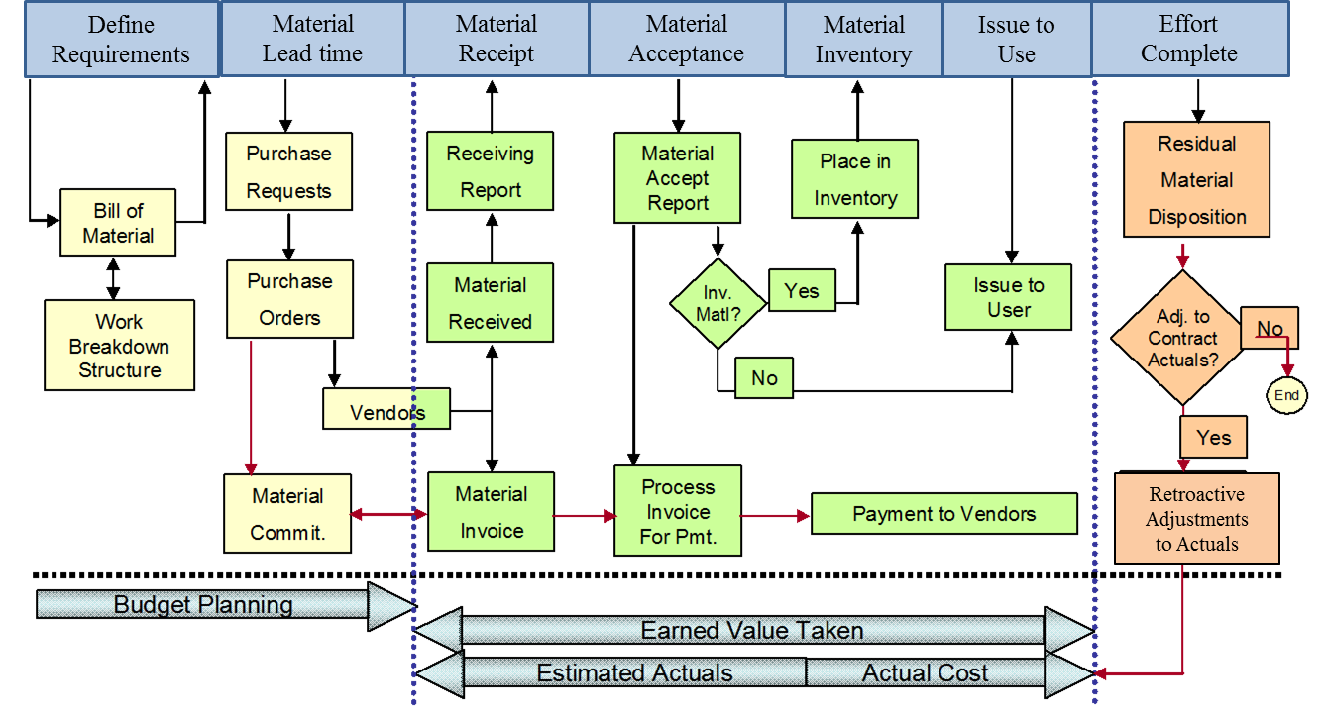
Figure L: Typical EVMS and Material Accountability
(Note: Figure does not reflect milestone progress payments)
Attributes
- The actual cost of work performed (ACWP) in the EVMS is reconcilable with the actual costs in the accounting system for material items.
- Actual costs must be recorded on the same basis in which budgets were assigned (BCWS) at the control account level at a minimum for material items.
- Control account plans demonstrate time-phased material budgets and earned value technique; these plans allow traceability of high dollar materials.
- Identify Material Categories and align those to the type of progressing methodology to be used, (i.e. point of receipt, inspection, and acceptance; point of issue, etc.) with the appropriate EVT.
- There is accountability for all material purchased for the program including material issues to control accounts, return of unused material, scrap quantity and disposition, and residual inventory.

Typical Work Products
- Priced Bill of Materials (BOM)/Indenture parts list for material
- Internal contractor performance reports reflecting material-related performance
- Control account plans (CAP)
- Material commitment reports, inventory reports, purchase orders, and payment records
- Residual material on hand or projected at completion
- Estimated actuals log
- Material control records
- Defined and documented categories of material
- Cost tool data
- Variance analysis reports

Analysis and Management Reporting Category

Overview of Analysis and Management Reporting Category and Guidelines
The Analysis and Management Reporting category focuses on management use of the EVM performance data to detect and act upon early technical, schedule, and/or cost deviations from the Performance Measurement Baseline (PMB). The six guidelines (22 – 27) that comprise this category establish the minimum requirements for generating and analyzing cost and schedule variances (guidelines 22 and 23), establishing and implementing corrective action plans (guideline 26), and maintaining credible Estimates at Completion (EAC) at both the control account and total program levels (guideline 27). These minimum requirements facilitate the Control Account Managers’ ability to identify cost and schedule performance drivers and to use that information to make informed programmatic decisions that will optimize the use of resources to accomplish the remaining work. As defined in DFARS 234.201 EVMS Policy, guidelines 23, 26, and 27 are high-risk guidelines.
The Analysis and Management Reporting guidelines further require the performance data to be accurately summarized from the control account level to the contractually mandated reporting level so that the same data being used to internally manage and execute the program is being communicated externally to the Government. This ensures all program stakeholders are informed of program progress and made aware of any problems and/or risks identified and planned management actions to address them (guideline 25).
Consideration of the impact of indirect cost performance on the overall cost of the program is also included in this category. The guidelines require indirect cost variances to be analyzed and their impacts to be factored into the Estimates to Complete (ETC) the remaining work (guideline 24). Lastly, the guidelines require the contractor to periodically evaluate and update ETCs and derive control account and program level EACs that reflect a valid projection of program cost. Timely and reliable EACs provide the program manager visibility into future resource needs and support the government’s ability to provide sufficient funding to the program (guideline 27).
Subsections 2.4.1.1 through 2.4.1.6 describe DoD’s intent and expectations for implementing each of the six Analysis and Management Reporting guidelines.

Guideline 22: Calculate Schedule Variance and Cost Variance
EVMS Category: Analysis and Management Reports
EVMS Standard Guideline(s): 2.4a | Calculate Schedule Variance and Cost Variance
At least on a monthly basis, generate the following information at the control account and other levels as necessary for management control using actual cost data from, or reconcilable with, the accounting system:
- Comparison of the amount of planned budget and the amount of budget earned for work accomplished. This comparison provides the schedule variance.

- Comparison of the amount of the budget earned and the actual (applied where appropriate) direct costs for the same work. This comparison provides the cost variance.
DoD Strategic Intent
Purpose of Guideline: To ensure accurate cost and schedule performance data is available on a periodic basis. This ensures program management can use the data to make assessments of program progress and the impacts from the technical, schedule and cost baseline deviations.

Management Value: The use of data that is traceable through EVMS subsystems helps to ensure that the variances calculated each month are a valid reflection of progress. Calculating and analyzing cost and schedule variances allows program management to assess the impact of deviations from the Performance Measurement Baseline (PMB) and to determine the necessity for corrective action(s) in order to achieve program objectives.

Intent of Guideline: The calculation of schedule and cost variances enables program management to assess any deviations to the PMB in order to avoid cost and schedule cost growths, or at least, mitigate their impact on the program’s objectives. At a minimum, cost and schedule variances are calculated at the control account level on a monthly basis for analysis and variance reporting. As work is completed based on assigned earned value techniques (see Guidelines 7 and 10), the corresponding budget value is “earned” and is represented as the Budgeted Cost for Work Performed (BCWP). As BCWP measures the work actually accomplished, it is the primary data element for which planned budgets (i.e. Budgeted Cost for Work Scheduled (BCWS)) and actual costs (i.e. Actual Cost of Work Performed (ACWP)) are compared to determine cost and schedule performance status. Variance analysis will provide early insight into cost and schedule status for improved visibility of program performance (see Guideline 23 for further information). The performance data used for variance analysis must be generated from the EVMS. To ensure cost and schedule variances are valid, the EVM method used to derive the BCWP must be consistent with the method used to plan and resource the associated work (see Guidelines 10 and 12) and that the applicable actual costs are reconcilable with the accounting system (see Guidelines 16 and 21).

Attributes
- The EVMS calculates variances, at a control account level (at a minimum), which includes schedule variance, cost variance, and variance at completion (as developed in Guideline 27).
- Performance measurement data is summarized from control accounts (at a minimum) through Work Breakdown Structure (WBS)/Organizational Breakdown Structure (OBS) hierarchy to the contract level.

Typical Work Products
- Internal monthly cost and schedule performance reports
- CPR/IPMR
- Cost tool data

Guideline 23: Analyze Significant Variances
EVMS Category: Analysis and Management Reports
EVMS Standard Guideline(s): 2.4b | Analyze Significant Variances
Identify, at least monthly, the significant differences between both planned and actual schedule performance and planned and actual cost performance, and provide the reasons for the variances in the detail needed by program management.
DoD Strategic Intent
Purpose of Guideline: To ensure management is identifying and analyzing significant cost and schedule variances in order to determine the primary factors driving performance. This will facilitate program management’s ability to forecast future cost and schedule performance as well as develop corrective action plans intended to regain program objectives.

Management Value: The ability to analyze deviations from the established plan permits management, at all levels, to rapidly and effectively implement corrective actions in an effort to regain contract objectives. Insight into future cost and schedule performance, based on the analysis of cost, schedule, and at complete variances, will be facilitated. The communication of programmatic earned value performance status enables program management to manage and control execution of the program and assess whether deviations from the technical, schedule, and budget baselines require management action. Without this visibility into and the understanding of plan deviations, the success of the contract can be jeopardized.

Intent of Guideline: Focused variance analysis provides program management insight into significant problem areas and highlights the potential need for management action regarding the future allocation of resources to mitigate potential or realized program risks. On at least a monthly basis, cost variances, schedule variances, and variances at completion (VAC) are calculated at the control account and summary levels for analysis and management reporting. Concept of the VAC is further discussed in Guideline 27. Variance analysis thresholds are established to quantify an acceptable and unacceptable range for deviating from the program’s performance measurement baseline (PMB). Cost variances, schedule variances, and VAC that exceed the internal/external established thresholds are considered significant enough to require in-depth analysis and possible management action. The EVMS needs to be able to have the capability to accurately calculate and analyze labor cost variances (rate and volume) and material cost variance (price and usage). Regardless of Government specified thresholds, the contractor shall apply variance analysis thresholds consistent with its EVM System Description and other internal procedures. Analyzing variances at the control account and summary levels enables program management to understand the impact of cost and schedule performance drivers at the point where budget, scope, and resources are actively managed.

The reporting of cost and schedule variances will identify the type and magnitude of the variance (i.e. value of schedule variance, cost variance, and VAC) and contains the following information for management evaluation:

- Explanation of root cause(s) of the variance.
  - For schedule variances, concurrent analysis of the integrated network schedule(s) is done to determine the status of specific activities, milestones, and critical events and to identify the factors contributing to the dollarized and time-based schedule variance.
  - Cost variance analysis should be at the element of cost at the control account and summary level, to include rate, price, and usage variances.
    - Rate Variance = (Budgeted Rate – Actual Rate) x Actual Hours
    - Volume Variance = (Budgeted Hours – Actual hours) x Actual Rate
  - For determining root cause of a material cost variance, price and usage analysis is useful to determine if the unit price of the material is more or less than originally budgeted or if the material usage is more or less than what was originally required. Quantity breakouts are most useful on programs procuring multiple items of the same part number, typical for production type contracts.
- Price Variance = (Earned Value Unit Price - Actual Unit Price) X Actual Quantity.
- Usage Variance = (Earned Value Quantity - Actual Quantity) X Earned Value Unit Price.

- Impact of the variance on the program including:
  - Short and long-term cost, schedule, and technical impact(s) on the control account, other dependent control accounts and Work Breakdown Structure (WBS) elements, and the total program.
  - For schedule variance, impact to the critical path (i.e. a delay in a critical activity’s completion affects the program completion), float, schedule margin (where applicable), contractual milestones and/or delivery dates.
  - Impact on the Estimate to Complete (ETC).

- Corrective actions taken or planned to address root cause, mitigate the impact, and status of corrective action implementation and closure. If no corrective action is to be taken, explanation of how impact will not adversely affect accomplishment of program objectives.

Attributes
- Schedule (time-based) and cost (budget-based) variances are identified and analyzed at control account and summary level.
- The variance analysis identifies the factors causing the variance (e.g., efficiency, rate, timing) and potential impacts.
- Schedule Variance is supplemented with Integrated Master Schedule (IMS) analysis, and assesses the impact to future activities on the critical path, near-critical paths, and driving paths.
- Identification of corrective actions and mitigation plans are done in a timely manner.
- Material cost variance analysis is substantiated from source records evaluating price and usage variance.

Typical Work Products
- Internal monthly cost and schedule performance/variance reports
- CPR/IPMR
- Cost tool data
- Integrated Master Schedule (IMS)
- Control account plans

Guideline 24: Analyze Indirect Cost Variances
EVMS Category: Analysis and Management Reports
EVMS Standard Guideline(s): 2.4c | Analyze Indirect Cost Variances
Identify budgeted and applied (or actual) indirect costs at the level and frequency needed by management for effective control, along with the reasons for any significant variances.
DoD Strategic Intent
Purpose of Guideline: To ensure indirect cost variances are regularly identified and reviewed for insight into their impact on overall cost performance. This will facilitate program management’s ability to forecast future indirect cost performance as well as develop corrective action plans intended to regain program objectives.

Management Value: The overall value to the contractor is visibility into the absorption of indirect costs that cannot be directly applied to a contract. Managing indirect costs on a continuing basis enables the contractor to adjust rates in a timely manner so as to complete an accurate allocation to individual programs/contracts. Program management must understand that ongoing indirect cost analysis provides visibility into potential indirect cost overruns and the opportunity to develop and implement management action plans. This effect must be considered when developing and analyzing Estimate to Complete (ETC).

Intent of Guideline: Indirect costs are allocated to a contract consistent with the procedures described in the contractors CAS Board (CASB) disclosure statement. Threshold identification and analysis of indirect cost variances are conducted at the level where overhead budgets have been established and where ongoing, periodic reviews of indirect cost performance are conducted. The results of the analysis of indirect cost variances provides program management visibility into the reasons for potential or realized indirect cost overruns that contribute to the contract’s overall cost and impacts to ETC. This analysis also enables the management team to take corrective actions to mitigate cost growth. Significant differences between actual indirect costs are adjusted and reflected in the EVMS cost performance reports in a timely manner.

Attributes
- Indirect cost variances by overhead category that exceed variance thresholds are reported monthly to include root cause analysis and corrective action plans.
- The results of indirect variance analysis are provided to program management for use in evaluating the cost variance.
- Analysis of cost variance driven by indirect cost rate and volume variances.

Typical Work Products
- Contractor’s CASB Disclosure statement
- Accounting Policies and Procedures
- Indirect Cost Variance Reports
- Forward Pricing Rate Agreement

Guideline 25: Summarize Performance Data and Variances for Management Reporting
EVMS Category: Analysis and Management Reports
EVMS Standard Guideline(s): 2.4d | Summarize Performance Data and Variances for Management Reporting
Summarize the data elements and associated variances through the program organization and/or work breakdown structure to support management needs and any customer reporting specified in the project.
DoD Strategic Intent
Purpose of Guideline: To ensure that program performance status can be accurately summarized from the control account level (at a minimum) through the Work Breakdown Structure (WBS) and Organizational Breakdown Structure (OBS) for program management insight and control as well as to meet customer reporting requirements.

Management Value: The availability of summarized EVMS data allows the government and the contractor to make management decisions based on the same information derived from the EVMS subsystems. Summarizing performance measurement data and variances allows program management to focus on potential or realized problem areas.

Intent of Guideline: It is critical that data used for internal management reporting and external customer reporting are derived from the same data resident in the EVMS. Accurately summarizing and reporting control account or summary level performance data and variance analysis provides program management insight into significant problem areas. This composite analysis will focus on the summarized lower level data and variances supporting management actions that cross WBS and OBS elements.

Attributes
- Performance measurement information is summarized from control account to the program level through WBS and OBS for program management analysis purposes.
- The data elements reconcile between internal and external reports.

Typical Work Products
- Internal Performance Reports
- CPR/IPMR
- Cost tool data

Guideline 26: Implement Corrective Actions
EVMS Category: Analysis and Management Reports
EVMS Standard Guideline(s): 2.4e | Implement Corrective Actions
Implement managerial action taken as the result of earned value information.
DoD Strategic Intent:
Purpose of Guideline: To ensure program management, starting with the program manager, is reviewing performance measurement data, implementing corrective action plans, and using the information for decision making purposes.

Management Value: A formalized approach to preparing problem analysis, establishing corrective action plans, and tracking their resolution ensures management’s visibility into program execution on a continuing basis. Early identification of cost, schedule, and technical risks permits program management to implement corrective action plans in a timely fashion. Analysis of timely and accurate data facilitates effective assessment and decision-making.

Intent of Guideline: Corrective action plans indicate that the program manager has recognized that a cost and/or schedule variance exists that is significant enough to require their management actions be taken through a closed-loop (identification through closure) corrective action management process. Corrective action plans provide the what, how, who, and when relative to management action(s) that will be taken to address identified root causes and alleviate or minimize their impact. The plans are documented, implemented, and monitored until resolution of the problem. To be effective, the program management process should ensure that the individuals responsible for implementing corrective actions have sufficient authority and control over the required resources. Performance measurement data should be used by all levels of management to promote effective program execution and cost, schedule and technical risks should be incorporated into a formalized risk management process. The program’s internal reports and reports forwarded to their customer must indicate the overall cost and schedule impacts of program issues. Implementing and then assessing whether corrective actions are having the desired effect is critical to ensuring the success of the program.

Attributes
- There is evidence of management decision-making based on the effective use and analysis of earned value information (at least on a monthly basis).
- Corrective action plans, based on variances, are tracked to resolution and closure.

Typical Work Products
- Internal Reports such as management action plans, review briefings, risk register, and corrective action tracking log
- CPR / IPMR Format 5
- Integrated Master Schedule (IMS)

Guideline 27: Maintain Estimate at Completion
EVMS Category: Analysis and Management Reports
EVMS Standard Guideline(s): 2.4f | Maintain Estimate at Completion
Develop revised estimates of cost at completion based on performance to date, commitment values for material, and estimates of future conditions. Compare this information with the performance measurement baseline to identify variances at completion important to company management and any applicable customer reporting requirements including statements of funding requirements.

DoD Strategic Intent
Purpose of Guideline: To ensure estimates of the cost to complete the remaining requirements on a program are periodically reassessed. A most likely estimate of the total cost for completing all authorized program work is maintained and reflects future impacts and risks/opportunities not yet captured in performance. Estimates to Complete (ETC) for the remaining work are time-phased in accordance with the expected completion dates and support funding requirements.

Management Value: A properly established and maintained Estimate at Completion (EAC) ensures continuing visibility into the cost, schedule, risks and opportunities, as well as the resource requirements (funding, labor resources, facilities, etc.) and contributes to program success for both the government and the contractor. Timely, accurate and reliable estimates support the government’s ability to provide sufficient funding to the program with minimal disruption and enhance internal management’s visibility into critical resource requirements (labor resources, facilities, etc.).

Intent of Guideline: The EAC is based on the actual costs of work performed (ACWP) to date plus an assessment of the ETC the remaining work including evaluating the type and quantity of resources required to complete program objectives. ETCs are developed at the work package level or where resources are identified (if lower than the work package level) and are added to the actual cost to calculate the EAC. ETC must contain resources that are time-phased commensurate with schedule forecast dates. EACs are summarized through the Work Breakdown Structure (WBS) and Organizational Breakdown Structure (OBS) to the program level. Program level EACs account for dollarized risks and opportunities that are related to the risk management process and are tracked at the program level but have not yet been realized and/or incorporated into the control account level. The Best Case, Worst Case, and Most Likely Management EACs shall address identified risks and estimates rather than merely project the expenditure of the balance of remaining MR. The substantiation of risks cannot be confused with the intent to expend MR. The Program Manager’s EAC used for the internal and external reporting should be based on the same risks and opportunities. Developing the EAC is a critical part of program management as it provides insight for future resource requirements when a program is experiencing differences from the baseline plan. EACs are not constrained by funding or negotiated contract costs.

Control account managers (CAMs) review and update control account level EACs monthly, based on the EVM performance metrics and variances analyzed (see Guidelines 22 and 23). Sometimes a financial analyst or planner is responsible for calculating EACs. This is acceptable if the EAC has been thoroughly reviewed and approved by the CAM. This analysis should focus on performance to date within the control account, an assessment of the effort to complete the remaining work, and an evaluation of the type and quantity of resources required to complete the effort. Maintenance of the control account level EACs provides program management with the assurance that projected costs for completing the work are credible and that any decisions regarding the allocation of future resources is based on valid data.

At least annually, or more frequently when performance indicates that the current estimate is invalid, an assessment of the contract level EAC, also known as a comprehensive or bottom up EAC, provides program management assurance that all factors impacting the total cost to complete program objectives have been considered. The comprehensive EAC (CEAC) should have a degree of formality that is differentiated from the monthly EAC process. This should include, but not be limited to, ground rules and assumptions for the CEAC approach, an overall schedule for completing the CEAC, identification of documentation that will be used to update the EAC, and the final approval process. This is done by considering many of the same factors included in the monthly evaluation at the control account level as well as:
- Evaluation of both direct and indirect performance to date efficiency achieved by performing organizations for completed work and comparing it to remaining budgets and scope of work.
- Assessment of commitment values for material to complete the remaining work.
- Evaluation of subcontractor assessments of cost to complete their efforts; for the major subcontracts, the prime contractor control account manager is responsible for ensuring timely and reliable EACs for situations when the subcontractor has not provided their most current information available
- Assessment of price and usage variance analysis when determining material estimates to complete.
- Incorporation of program level risks and opportunities that have not yet been incorporated into the cost and schedule baseline.
- Facility improvements or other capital investments that may improve cost and schedule performance in the future.
- Estimation of future conditions to derive the most accurate estimate at completion; e.g., projected rate changes, process improvements that may result in reduced costs, or other economic factors that may impact future costs.

Attributes
- CEAC is developed at a minimum annually, to include evaluation of remaining contract scope (including control accounts, Summary Level Planning Packages (SLPP), and Undistributed Budget (UB), reassessing all EAC assumptions, taking into account the past performance, risks/opportunities and resource considerations. This shall be accomplished by the managers’ assigned responsibility for each segment of work and all elements of costs.

- ETC will be assessed monthly, at a minimum, and updated as needed to include but not limited to schedule/budget changes, incorporation of risks/opportunities and resource considerations. This shall be accomplished and generated at the work package level or where resources are identified (if lower than the work package level) by the control account manager and shall also incorporate any required changes to EACs for UB, planning packages (PP), and SLPPs.

- The indirect rates used for ETCs/EACs shall consider the latest information available.

- Projected identified risks in the Program Manager’s EAC are adequately substantiated from the risks and opportunity management process and/or the Program Manager’s assessment.

- Contractor’s external EAC and internal EAC reconcile and have clear traceability based on the identified risks and opportunities.

Typical Work Products
- Risk/opportunity register
- Basis of Estimates (BOE) (if required for substantiation of CEAC)
- Bill of Materials (BOM)
- Control account plans reflecting time-phased ETC
- Integrated master schedule (IMS) focused on schedule forecast dates
- Internal and external management reports, such as IPMR Formats 1, 2, 4, 5
- Subcontractor reports containing subcontract EACs
- Ground rules and assumptions supporting comprehensive EACs
- Cost tool data
- Contract Funds Status Report (CFSR)
- Forward Pricing Rate Agreement/Proposal
- Indirect Cost Variance Reports

Revisions and Data Maintenance Category

Overview of Revisions and Data Maintenance Category and Guidelines
The Revisions and Data Maintenance category focuses on maintaining an accurate and reliable Contract Budget Base (CBB) and Performance Measurement Baseline (PMB) as the program evolves throughout its period of performance. The objective of the five guidelines (28 – 32) that comprise this category is to establish the requirements for implementing a formal change control process that will preserve the integrity of the PMB and corresponding EVM data. As defined in DFARS 234.201 EVMS Policy, guidelines 28, 30, and 32 are high-risk guidelines.
As the PMB represents the contractor’s and Government’s agreed-upon plan for how contractually authorized work is to be accomplished and measured, any changes to that plan must be formally controlled and properly documented using a systematic approach (guideline 31). Implementation of the Revisions and Data Maintenance guidelines requires the contractor to use a disciplined change control process that maintains the integrity of cost and schedule data when incorporating authorized revisions to the program’s scope, schedule, and/or budgets (guideline 29). To sustain the predictive nature of the EVM data and its use in conducting credible trend analysis, the guidelines also require that retroactive changes to the data be controlled and limited to only certain circumstances (guideline 30).
The source of revisions to the PMB can be either internally or externally driven and may affect all categories of an EVMS. It is important that these authorized baseline revisions be documented, managed, tracked and reported to the program manager and the government in a timely matter (guideline 32). Ensuring authorized contractual changes are incorporated into all affected budget, schedules, work authorizations, and other program documentation in a timely manner prior to the commencement of that work ensures that the PMB reflects all authorized work scope (guideline 28). The Revisions and Data Maintenance guidelines ensure that the PMB reflects the most current plan for accomplishing the effort thus providing credible performance measurement data that management can rely on to make program-related decisions.
Subsections 2.5.1.1 through 2.5.1.5 describe DoD’s intent and expectations for implementing each of the five Revisions and Data Maintenance guidelines.

Guideline 28: Incorporate Changes in a Timely Manner
EVMS Category: Revisions and Data Maintenance
EVMS Standard Guideline(s): 2.5a | Incorporate Changes in a Timely Manner
Incorporate authorized changes in a timely manner, recording the effects of such changes in budgets and schedules. In the directed effort prior to negotiation of a change, base such revisions on the amount estimated and budgeted to the program organizations.

DoD Strategic Intent
Purpose of Guideline: To ensure authorized changes are accurately incorporated into the Contract Budget Base (CBB) and program schedule in a timely and systematic manner. Implementing a disciplined change control process assures that the CBB (Performance Measurement Baseline (PMB) + Management Reserve (MR)) is up to date and that performance measurement data reflects all authorized work scope.

Management Value: A properly maintained CBB is crucial to effective program management. The timely and accurate incorporation of contractual changes ensures that the information generated from the execution of the baseline plan provides an accurate picture of progress and facilitates appropriate management actions and decisions.

Intent of Guideline: The timely and accurate incorporation of contractual changes into the PMB and program schedule maintains the integrity of the baseline plan. Undistributed Budget (UB) will be distributed to Summary Level Planning Packages (SLPPs) and/or control accounts in a timely manner following Authorization to Proceed (ATP) for a change order or letter contract or negotiations and definitization of a supplemental agreement. Authorized changes are incorporated into schedules, budgets, work authorization documents, and other program documentation as needed to properly reflect the new work scope being executed. This provides program management performance measurement data that accurately reflects the status of all currently authorized work.

There may be instances where scope is not fully defined and it is not practical for the budget authority to be distributed into SLPP and/or control accounts. An example may be for technology insertions or study efforts where this budget authority may reside in UB for a sustained period of time. Work that the customer and contractor agree can no longer be executed as planned in distributed budget within the contract period of performance may be put into UB pending settlement and disposition through contractual negotiations and supplemental agreement. This may require time before the UB is reduced following negotiations. Changes should never result in negative UB or MR values. See Guideline 14 for additional information on UB.

The changes to the CBB in the form of Authorized Unpriced Work (AUW) must be sufficient to represent a realistic plan to capture all authorized scope on contract. These budgets are applied without the constraint of funding or not-to-exceed (NTE) limitations, but are related to the value of the proposal incorporated as AUW. Just as incrementally funded contracts should establish a CBB for the entire scope of work, AUW must represent all authorized scope. The contractor responds to the AUW authorization by placing the near term budget into the applicable control accounts and the remainder in undistributed budget until negotiation and incorporation into the contract (and removal from AUW). After contract definitization, any AUW budget remaining in UB is planned and budgeted into control account(s), SLPP(s), or MR as soon as practical.

Attributes
- Authorized changes are incorporated in the PMB and the Integrated Master Schedule (IMS) as soon as practicable.
- UB is distributed to or removed from control accounts or SLPP's as quickly as practicable.
Typical Work Products
- Contract Modifications and amended Statement of Work (SOW)
- Baseline change documentation
- Work Breakdown Structure (WBS), Organizational Breakdown Structure (OBS), Responsibility Assignment Matrix (RAM), Work Authorization Documentation, IMS, Control Account Plans
- Program Change Control Logs
- Internal management reports
- Internal Contract level authorization (above control account work authorization)
- CPR/IPMR
- Integrated Master Schedule (IMS)

Guideline 29: Reconcile Budgets
EVMS Category: Revisions and Data Maintenance
EVMS Standard Guideline(s): 2.5b | Reconcile Budgets
Reconcile current budgets to prior budgets in terms of changes to the authorized work and internal replanning in the detail needed by management for effective control.
DoD Strategic Intent
Purpose of Guideline: To ensure the ongoing integrity of the Contract Budget Base (CBB), budget traceability throughout the lifecycle of a program must be maintained. Current budgets must reconcile to prior budgets in terms of changes to work scope, resources applied, and schedule so that the impact of contract changes and internal replanning on overall program growth is visible to all stakeholders.

Management Value: The need for accurate performance measurement requires that the CBB) maintain a level of accuracy and relationship to the contract with the government. As changes are made to the contract, the CBB must be adjusted by the amount of change in order for the communication between the two parties to remain valid.

Intent of Guideline: Budget changes are controlled and understood in terms of their impact on scope, schedule, and resources. Current budgets must reflect current levels of authorized work based on resources needed to complete that work and be traceable to original authorized budgets and control account budgets. The use of contract budget logs will assist the contractor in meeting the reconciliation requirements of this guideline. The ability to track budget values for both internal and external changes is necessary to properly maintain the CBB from contract start to completion.

Baseline changes must be traceable with authorizing documents and through supporting budget log(s). When MR transactions are part of a baseline change, it must be appropriate and accurately tracked in applicable logs and reports. The use of the Undistributed Budget (UB) account to process external (contractual) changes provides traceability and enables reconciliation from the current value of the CBB back to the original value.

Rolling wave is the continuous planning process for converting Summary Level Planning Packages (SLPP) into control accounts and control account planning packages into work packages and is used to ensure work is detail planned at the earliest practical time. When implementing rolling wave planning, planning horizons, based on the natural work flow and interim goals, are used to decompose and detail plan the work to an end objective. The extent of the detailed planning is determined by the nature of the work, and should be planned as far in the future as practical. Once work packages have been defined and budgeted, controls should be established to minimize further changes to budgets, schedule, or scope of work, specifically during the freeze period.

When the rolling wave process is executed on control account planning packages, there must be a means to reconcile the new planning (scope, schedule, and resources) in the control account to previous values for work packages and planning packages. This is especially true if the resulting total value of the control account changes as a result of this planning process.

In order to ensure Performance Measurement Baseline (PMB) stability for accurate performance measurement, it is necessary to establish a freeze period. At a minimum, a freeze period is no less than the current accounting period plus one accounting period. During the freeze period, changes to the PMB are limited to routine accounting adjustments, definitization of customer-approved contract actions, rate changes, economic price adjustments, or correction of errors. The primary intent of any freeze period is to ensure that the integrity of the PMB is maintained. However the freeze period is determined, it shall be established to ensure that the detail planning and baseline maintenance is conducted beyond the current period.

Attributes
- Current budgets resulting from changes to the authorized work and/or internal re-planning are traceable to prior budgets.
- MR and/or UB transactions are appropriate and accurately tracked in applicable logs and reports.
- The most current indirect rates are incorporated in the PMB.

Typical Work Products
- Contract Modifications
- Program Change Control Logs
- Updated work authorization documentation
- Updated Control Account Plans
- Baseline change documentation
- Cost tool data
- Budget logs

Guideline 30: Control Retroactive Changes
EVMS Category: Revisions and Data Maintenance
EVMS Standard Guideline(s): 2.5c | Control Retroactive Changes
Control retroactive changes to records pertaining to work performed that would change previously reported amounts for actual costs, earned value, or budgets. Adjustments should be made only for correction of errors, routine accounting adjustments, effects of customer or management directed changes, or to improve the baseline integrity and accuracy of performance measurement data.

DoD Strategic Intent
Purpose of Guideline: To ensure retroactive changes to previously reported data are limited to maintain the credibility of using data to project future cost and schedule performance. The changes should be limited to routine accounting adjustments, definitization of customer-approved contract actions, rate changes, economic price adjustments, or correction of errors.

Management Value: Controlling retroactive changes (including those in the current period) maintains the validity of historic EVM cost and schedule variance trends in reflecting true program performance. A stable baseline and performance information against that baseline are essential to both internal and external management if informed decisions are going to be made based on the analysis of the information produced by the EVMS. Establishment of internal controls over retroactive budget and/or performance adjustments will help maintain visibility of overall project variance from plan. Uncontrolled changes to the information limit the ability to conduct predictive analysis of the data.

Intent of Guideline: Retroactive changes involve adjustments to previously reported values for actual costs, earned value, and/or budgets related to work performed. Retroactively changing data may be necessary under certain conditions and is controlled by the contractor’s formal change control procedures that ensure existing cost and schedule variances are not arbitrarily eliminated. Adjustments resulting from definitization of contract actions should be limited to affected work scope budgets. Retroactive adjustments due to rate changes are only made to actual cost of work performed (ACWP). The cumulative values for the budgeted cost for work scheduled (BCWS) and budgeted cost for work performed (BCWP) are not adjusted for direct or indirect cost rate increases or decreases. This enables credible trend analysis for projecting future cost and schedule performance and accurate estimates at complete (EACs).

If a contractor applies the concept of a Single Point Adjustment (SPA), i.e. to set BCWS and BCWP equal to ACWP, then proper controls need to be defined and practiced. The contractor should also define the process for internal replanning, related to setting BCWS equal to BCWP and not the reverse, when eliminating schedule variances. SPAs should be accomplished sparingly, and it should be noted that there is no absolute requirement to set all variances to zero in order to implement an SPA. The contractor should provide advance notification to the contracting officer prior to implementation of SPA.

Attributes
- Change control process that controls retroactive changes to current and previously reported values for actual costs (ACWP), earned value (BCWP), or budgets (BCWS), including approval.

Typical Work Products
- Program Budget and Change Control Logs
- CPR/IPMR Formats 1, 2, 3, and 5
- Cost tool data

Guideline 31: Prevent Unauthorized Revisions
EVMS Category: Revisions and Data Maintenance
EVMS Standard Guideline: 2.5d | Prevent Unauthorized Revisions
Prevent revisions to the program budget except for authorized changes.
DoD Strategic Intent
Purpose of Guideline: To prevent the incorporation of unauthorized revisions into the Contract Budget Base (CBB).

Management Value: Disciplined implementation ensures the information that flows from the execution of the plan, represented by the program budget known as the Contract Budget Base (CBB), accurately represents progress in the completion of the authorized scope against the contractual schedule. This ensures the program manager is managing with performance measurement data that accurately reflects only the authorized contractual scope of work. In order to prevent unauthorized revisions to the CBB, prior approval is required between the contractor and the Government for an Over Target Baseline (OTB). This reinforces the mutual management of the program.

Intent of Guideline: The consistent and systematic use of a baseline change control process to implement changes prevents unauthorized revisions to the time-phased performance measurement baseline (PMB). Unauthorized revisions could inadvertently result in baseline budgets or schedules that exceed the time-phased budget value of the program plan.

There may be situations when available budgets for the remaining work are insufficient for successful execution of the current plan, thus resulting in unrealistic or un-executable assessments of program performance.. In these situations, the program manager may conclude that the PMB no longer provides meaningful cost and/or schedule performance data. It may be necessary for the Total Allocated Budget (TAB) for the work to exceed the CBB, a condition known as an OTB, and/or for the baseline schedule to exceed contract milestones, a condition known as an Over Target Schedule (OTS). The process of establishing either an OTB and/or OTS is called Formal Reprogramming and may be considered where improved insight and management control would result. A thorough analysis of program status is necessary before the consideration of the implementation of an OTB. Requests for establishing an OTB or an OTS must be initiated by the contractor and approved by the Government. Subcontractor flowdown, where it relates to formal reprogramming, is the Prime Contractor’s responsibility to approve and manage. Implementing an OTB and/or OTS does not change the contractual requirements but merely serves to improve management of the remaining work. For special considerations to reset variances or implement a Single Point Adjustment for an OTB/S, refer to Guideline 30.

Attributes
- Contractual budget values (CBB or TAB) are only revised through contractual authorization.

Typical Work Products
- Contract Modifications
- Work Breakdown Structure (WBS), Organizational Breakdown Structure (OBS), work authorization documentation, Integrated Master Schedule (IMS), Control Account Plan
- Change control logs
- Basis for OTB/OTS/SPA

Guideline 32: Document PMB Changes
EVMS Category: Revisions and Data Maintenance
EIA Standard Guideline: 2.5e | Document PMB Changes
Document changes to the performance measurement baseline.
DoD Strategic Intent
Purpose of Guideline: To ensure all changes to the Performance Measurement Baseline (PMB) are transparent to all program stakeholders and are documented throughout all internally and externally affected systems and reports.

Management Value: Effective implementation of this guideline ensures control and auditability by the program in maintaining the internal plan for executing the authorized scope within the established schedule. This enhances internal and external management confidence in the performance data that is used to make programmatic decisions. Using a disciplined, systematic change control process to document PMB changes provides assurance that all program stakeholders are using the same technical, schedule, and cost baselines to measure contract performance.

Intent of Guideline: The PMB should always reflect the most current plan for accomplishing the effort. Authorized changes must be incorporated into the plan and authorization documents updated accordingly prior to the commencement of work. Changes made to the PMB must be traceable through documentation to reconcile with the initial PMB. A change control process governs when and how technical and programmatic changes are applied to the PMB and the program schedule.

Attributes
- Timely and authorized changes incorporated into the PMB are properly documented and traceable throughout the system in accordance with procedures.
Typical Work Products
- CPR/IPMR
- Program Change Control Logs, Baseline Change Logs / Requests, change documentation
- Work Breakdown Structure (WBS), Organizational Breakdown Structure (OBS), Work authorization documentation, Integrated Master Schedule (IMS), Control Account Plan
- Cost tool data

GLOSSARY

TERM | DEFINITION
ACCOUNTING PERIOD | The period of time during which actuals will be collected and transferred into the EVMS for reporting purposes.
ACTUAL COST(AC) | The costs actually incurred and recorded in accomplishing work performed also referred to as Actual Cost of Work Performed (ACWP).
ACTUAL COST OF WORK PERFORMED (ACWP) | The costs actually incurred and recorded in accomplishing the work performed within a given time period. ACWP reflects the applied costs that may be expressed as a value for over a specific period or cumulative to date. (See also Estimated Actuals.)
ACTUAL COMPLETION DATE | The date on which a milestone or scheduled work task is completed.
ACTUAL DIRECT COSTS (ADC) | Those costs identified specifically with a contract, based upon the contractor's cost identification and accumulation system as accepted by the cognizant Defense Contract Audit Agency (DCAA) representatives (See Direct Costs).
ALLOCATED BUDGET | See Total Allocated Budget
ELECTRONIC INDUSTRIES ALLIANCE (EIA) STANDARD-748 Earned Value Management System (EVMS) | EIA-748 provides the standard for implementing an EVMS.
APPORTIONED EFFORT (AE) | Effort that by itself is not readily measured or divisible into discrete work packages but is related in direct proportion to the planning and performance on other measured effort
AUTHORIZATION TO PROCEED (ATP) | Official authority for the contractor to begin work. It is usually issued by the procuring contracting officer.
AUTHORIZED UNPRICED WORK (AUW) | AUW is the estimated cost (excluding fee or profit) for contract changes that have been approved by the government contracting officer but have not yet been fully negotiated. This type of change is also called: changes orders, not to exceeds, and undefinitized change orders.
AUTHORIZED WORK | That effort that has been definitized and is on contract plus that effort for which definitized contract costs have not been agreed to but for which written authorization has been received.
BASELINE | See Performance Measurement Baseline.
BASELINE SCHEDULE | The IMS shall have baseline start and finish dates for all tasks within the PMB and those dates shall be consistent with the start and finish of the cost baseline. (See Performance Measurement Baseline.)
BASIS OF ESTIMATE (BOE) | A BOE is a process used in the field of program management by which members of the project team, usually estimators, project managers, or cost analysts, calculate the total cost of the project.
BETTER BUYING POWER (BBP) | Better Buying Power (BBP) is the implementation of best practices to strengthen the Defense Department's buying power, improve industry productivity, and provide an affordable, value-added military capability to the Warfighter.
BILL OF MATERIAL (BOM) | A listing of material items required to complete the production of a single unit. When actual or expected prices are applied, it becomes the Priced Bill of Material (PBOM).
BUDGET AT COMPLETION (BAC) | The sum of all budgets established for the contract through any given level. When tied with a level it becomes control account BAC, Performance Measurement Baseline (PMB) BAC, etc. (See Total Allocated Budget.)
BUDGETED COST FOR WORK PERFORMED (BCWP OR EARNED VALUE) | The sum of the budgets for completed work packages and completed portions of open work packages, plus the applicable portion of the budgets for level of effort and apportioned effort. May be expressed as a value for a specific period or cumulative to date.
BUDGETED COST FOR WORK SCHEDULED (BCWS OR PLANNED VALUE) | The sum of the budgets for all work packages, planning packages, etc., scheduled to be accomplished (including in-process work packages), plus the amount of level of effort and apportioned effort scheduled to be accomplished within a given time period. Also referred to as Planned Value. May be expressed as a value for a specific period, or cumulative to date
COGNIZANT FEDERAL AGENCY (CFA) | CFA refers to the Federal agency that, on behalf of all Federal agencies, is responsible for determining EVMS compliance as defined in DFARS 242.302 (a)(S71).
COMPLIANCE | The continuing implementation, operation, and maintenance of the contractor’s EVMS in accordance with the 32 EVMS guidelines in EIA-748.
CONTRACT BUDGET BASE (CBB) | The sum of the negotiated contract cost plus the estimated cost of authorized unpriced work. This represents the total amount of performance measurement budget that may be allocated to contract work. (See Total Allocated Budget).
CONTRACT DATA REQUIREMENTS LIST (CDRL): | A compilation of all data requirements, made part of the contract, and which the contractor is obligated to deliver to the Government.
CONTRACT FUNDS STATUS REPORT (CFSR): | The CFSR supplies funding data about defense contract to government Program Managers (PM). Data provided to the PM from the contractor includes: [1] Updating and forecasting contract funds requirements; [2] Planning and decision making on funding changes in contracts;[3] Developing funds requirements and budget estimates in support of approved programs; [4] Determining funds in excess of contract needs available for deobligation; [5] Obtaining rough estimates of termination costs; [6] Determining if sufficient funds are available by fiscal year to execute the contract
CONTRACT PERFORMANCE REPORT (CPR) | A contractually required report, prepared by the contractor, containing performance information derived from the internal EVMS that provides status of progress on the contract (DI-MGMT-81466A). (See also Integrated Program Management Report (IPMR).
CONTRACT WORK BREAKDOWN STRUCTURE (CWBS) | The complete WBS for a contract. It includes the DoD approved WBS for reporting purposes and its discretionary extension to lower levels by the contractor, in accordance with government direction and the contract work statement. It provides for the product-oriented decomposition of contract work into major elements that include all the hardware, software, data and/or services that are the responsibility of the contractor.
CONTRACT WORK BREAKDOWN STRUCTURE (CWBS) DICTIONARY | A contractually required document prepared by the contractor that describes and defines the elements in the CWBS.
CONTRACTOR | An entity in private industry which enters into contracts with the Government. In this guide, the word also applies to Government-owned, Government-operated activities which perform work on major defense programs.
CONTROL ACCOUNT (CA) | The control account is the intersection of one WBS and one OBS representing a discrete portion of program scope assigned to an individual manager. The control account is the minimum level where technical, schedule, and cost responsibility exists
CONTROL ACCOUNT MANAGER (CAM) | A single manager within the contractor’s organizational structure that has been given the authority and responsibility to manage one or more control accounts.
CONTROL ACCOUNT PLAN | A control account plan is a tool used to create a plan for accomplishing all of the work within a control account. Each control account within a control account plan has a specific scope of work as defined in the program’s WBS, schedule, and time-phased budget.
COST ACCOUNTING STANDARDS (CAS) | Requirements established by the CAS Board to ensure consistent and proper accounting for direct and indirect costs applied to government contracts.
COST ACCOUNTING STANDARDS BOARD (CASB | The CASB is an independent statutorily-established (41 U.S.C. 1501 et seq., formerly, 41 U.S.C. 422) board. The Board has the exclusive authority to make, promulgate, and amend cost accounting standards and interpretations designed to achieve uniformity and consistency in the cost accounting practices governing the measurement, assignment, and allocation of costs to contracts with the United States.
COST ACCOUNTING STANDARDS BOARD (CASB) DISCLOSURE STATEMENT | A CASB Disclosure Statement is a written description of a contractor's cost accounting practices and procedures. In general, it is required for fully CAS covered contractors and must be completed prior to the award of a CAS covered contract of $50 million or more.
COST AND SOFTWARE DATA REPORTING (CSDR): | CSDRs are the primary means by which the Department of Defense (DoD) collects data on the costs that contractors incur on DoD programs. CSDR reporting and processing requirements are determined by Acquisition Category (ACAT) program category and the value of individual contracts and subcontracts within the program.
COST VARIANCE | A metric for showing cost performance derived from earned value data. It is the mathematical difference between earned value (BCWP) and actual cost (ACWP) (cost variance = earned value - actual cost.) A positive value indicates a favorable condition and a negative value indicates an unfavorable condition. It may be expressed as a value for a specific period of time or cumulative to date.
CRITICAL DESIGN REVIEW (CDR) | The CDR assesses design maturity, design build-to or code-to documentation, and remaining risks and establishes the initial product baseline. It will be used as the decision point that the system design is ready to begin developmental prototype hardware fabrication and/or software coding with acceptable risk.
CRITICAL PATH | A sequence of discrete work packages and planning packages (or lower level tasks/activities) in the network that has the longest total duration through an end point that is calculated by the schedule software application. Discrete work packages and planning packages (or lower level tasks/activities) along the critical path have the least amount of float/slack (scheduling flexibility) and cannot be delayed without delaying the finish time of the end point effort. Essentially ‘Critical Path’ has the same definition as ‘Program Critical Path’ with the exception that the end point can be a milestone or other point of interest in the schedule. Example: a critical path could be run to PDR, CDR, and/or First Flight, etc. within a System Development Demonstration contract.
CRITICAL PATH ANALYSIS | A network analysis technique used to predict project duration by analyzing which sequence of activities (which path) has the least amount of scheduling flexibility (the least amount of float). See Network Schedule.
CODE OF FEDERAL REGULATIONS TITLE 48 | Is the codified U.S. Federal laws and regulations that are in effect as of the date of the publication pertaining to the Federal Acquisition Regulations System or FARS.
DEFENSE ACQUISITION GUIDEBOOK (DAG) | The Defense Acquisition Guidebook is an interactive, web-based capability designed to provide the acquisition workforce and their industry partners with an instant on-line reference to best business practices as well as supporting policy, statute, and lessons learned.
DEFENSE CONTRACT AUDIT AGENCY (DCAA) | The Defense Department organization tasked with monitoring a contractor’s design and implementation of an acceptable accounting system.
DEFENSE CONTRACT MANAGEMENT AGENCY (DCMA): | The Defense Contract Management Agency is the Department of Defense (DoD) component that works directly with Defense suppliers to help ensure that DoD, Federal, and allied government supplies and services are delivered on time, at projected cost, and meet all performance requirements.
DEFENSE FEDERAL ACQUISITION REGULATION SUPPLEMENT (DFARS) | The DFARS contains requirements of law, DoD-wide policies, and delegations of FAR authorities, deviations from FAR requirements, and policies/procedures that have a significant effect on the public.
DEPARTMENT OF DEFENSE (DoD) | The Department of Defense is an executive branch department of the federal government of the United States charged with coordinating and supervising all agencies and functions of the government concerned directly with national security and the United States Armed Forces.
DIRECT COSTS | The costs or resources expended in the accomplishment of work, which are directly charged to the affected program.
DISCRETE EFFORT | Tasks related to the completion of specific end products or services and can be directly planned and measured. (Also may be known as work packaged effort.
DoD INSTRUCTION 5000.02 (DoDI 5000.2) | The Department of Defense’s Operation of the Defense Acquisition System that establishes and describes policy for the management of all acquisition programs in DoD
DUE DATE | The date a milestone or task is scheduled to be completed.
EARNED VALUE (EV): | The value of completed work expressed in terms of the budget assigned to that work, also referred to as Budgeted Cost for Work Performed (BCWP).
EARNED VALUE MANAGEMENT (EVM) | A program management methodology that uses the earned value information generated from an EVM System (EVMS) to assess program progress in an objective manner that facilitates and informs program management decisions that will influence contract performance
EARNED VALUE MANAGEMENT SYSTEM (EVMS) | An integrated management system that integrates the work scope, schedule, and cost parameters of a program in a manner that provides objective performance measurement data. It measures progress objectively with earned value metrics; accumulates actual costs; allows for analysis of deviations from plans; facilitates forecasting the achievement of milestones and contract events; provides supporting data for forecasting of estimated costs; and fosters discipline in incorporating changes to the baseline in a timely manner.
EARNED VALUE MANAGEMENT SYSTEM GUIDELINES | The 32 guidelines contained in the EIA-748 (current version) Standard that establish the requirements for a contractor's EVMS.
EARNED VALUE TECHNIQUE (EVT) | Earned Value Technique is a specific technique (e.g. Milestone Method, Percent Complete, 50/50, 0/100, Units Complete, Apportioned effort, LOE, etc.) selected to represent the objective completion of work scope in a specific work package and/or control account.
ELEMENTS OF COSTS (EOC) | Specific function (or a group of functions) which is considered a specific entity for the purpose of estimating, controlling, and reporting costs by cost elements (direct labor, material, indirect costs, etc.)
ENTERPRISE RESOURCE PLANNING (ERP) | An (ERP) is a business process management tool that allows a contractor to use a system of integrated applications to manage the business and automate many back office functions related to technology, services and human resources.
ESTIMATE AT COMPLETION (EAC) | The current estimated total cost for program authorized work. It equals actual cost plus the estimated costs to complete (Estimate To Complete) authorized work remaining.
ESTIMATE TO COMPLETE (ETC) | Estimate of costs to complete all work from a point in time to the end of the program.
ESTIMATED ACTUALS (EA) | A value entered into the EVMS to represent actual costs for material and/or subcontracted items for which earned value has been taken but invoices or billings have not entered the accounting system.
ESTIMATED COST (ESTIMATED ACTUAL) | Also known as ESTIMATED ACTUAL. An anticipated cost for specified work scope.
EXPECTED COMPLETION DATE | The date a scheduled milestone or task is currently expected to be completed.
EXTENDED SHIP WORK BREAKDOWN STRUCTURE (ESWBS) | The extended Ship Work Breakdown Structure depicts the breakdown of work scope for work authorization, tracking, and reporting for shipbuilding construction programs.
FORWARD PRICING RATE AGREEMENT (FPRA) | A Forward Pricing Rate Agreement (FPRA) is an agreement between a contractor and a government agency in which certain indirect rates are established for a specified period of time. These rates are estimates of costs and are used to price contracts and contract modifications.
FREEZE PERIOD | A period of time when baseline changes are not allowed. See Guideline 29 for information on the four exceptions to making baseline changes within the freeze period.
GENERALLY ACCEPTED ACCOUNTING PRINCPLES (GAAP) | General Accepted Accounting Principles are a set of accounting principles, standards and procedures that companies use to compile their financial statements. GAAP are a combination of authoritative standards (set by policy boards) and represent the commonly accepted ways of recording and reporting accounting information
GENERAL ACCOUNTING LEDGER | A general ledger is a complete record of financial transactions over the life of a company. The ledger holds account information that is needed to prepare financial statements, and includes accounts for assets, liabilities, owners' equity, revenues and expenses.
GENERAL & ADMINISTRATIVE (G&A) | An indirect rate established by the contractor that allocates the cost of corporate home office expenses to all contracts.
HIGH VALUE MATERIAL | High-value items such as major components or assemblies are frequently scheduled for delivery in accordance with the assembly line schedule. Items of this type are not usually scrapped if found defective, but are returned to the supplier for rework or repair. Under the applied direct cost approach, the costs of such items may be considered as applied direct material costs at the time they are received provided they are either scheduled for use within 60 days or are specifically identified to a unique, serially-numbered end item.
HORIZONTAL INTEGRATION | Demonstrates that work is planned in a logical sequence considering the interdependencies among work packages and planning packages (or lower level tasks/activities), ensuring that the overall schedule is rational, and provides methodology to evaluate the impact of current schedule status on subsequent work packages and planning packages (or lower level tasks/activities) and milestones. Horizontal integration depicts schedule dependencies and constraints, focusing on relationships within the same scheduling level including between different program elements such as “hand-offs” of products between IPTs.
INDIRECT COSTS | Indirect costs are for common activities that cannot be identified specifically against a particular program or activity and must be controlled and budgeted at a functional or organizational level. All indirect costs are recorded within the accounting system and reconciled accordingly (See GL 16 for reconciliation). Costs which because of their incurrence for common or joint objectives, are not readily subject to treatment as direct costs. This term is further defined in FAR 31.203.
INTEGRATED BASELINE REVIEW (IBR) | A joint Government/contractor review to assess the realism and accuracy of the integrated performance measurement baseline (work, schedule, budget, and risk
INTEGRATED MASTER PLAN (IMP) | An event-driven plan that documents the significant accomplishments necessary to complete the work and ties each accomplishment to a key program event.
INTEGRATED MASTER SCHEDULE (IMS) | The Integrated Master Schedule is an integrated, networked schedule containing all of the detailed activities necessary to accomplish the objectives of a program. When coupled with the Integrated Master Plan, it provides the time spans needed to complete the accomplishments and criteria of the Integrated Master Plan events. The Integrated Master Schedule normally contains all levels of schedules for the program (master, immediate, and detailed).
INTEGRATED PRODUCT TEAM (IPT) | A multidisciplinary team assigned management responsibility for one or more elements of an acquisition program.
INTEGRATED PROGRAM MANAGEMENT REPORT (IPMR) | A contractually required report, prepared by the contractor, containing performance information derived from the internal EVMS. Provides status of contract performance measurement of cost and schedule (DI-MGMT- 81861).
INTELLIGENCE COMMUNITY (IC) | The Intelligence Community consists of DoD agencies (NGA, NRO, NSA) which are responsible for ensuring common best practices are in place for conducting and participating in EVM compliance and surveillance reviews as well as providing consistency in the application of EVM by the members of the IC.
KEY PERFORMANCE PARAMETERS (KPPs) | Key Performance Parameters are key system capabilities that must be met in order for a system to meet its operational goals. Each KPP is supported by operational analysis that takes into account technology maturity, fiscal constraints, and schedule before determining threshold and objective values.
LEVEL OF EFFORT (LOE) | Unlike discrete and apportioned work, LOE work is defined as having no measurable output or product that can be discretely planned and objectively measured at the work package level. Therefore, LOE is limited only to those activities that are unable to be measured discretely.  Effort of a general or supportive nature for which progress cannot be measured and that does not produce definite end products. Typical examples are supervision, program administration, contract administration, and other support type activities.
MAJOR DEFENSE ACQUISITION PROGRAM (MDAP) | A Major Defense Acquisition Program is a program that meets or exceeds the ACAT I requirements in DoD Instruction 5000.02 "Operation of the Defense Acquisition System" and is classified as a MDAP by the Milestone Decision Authority (MDA) or Under Secretary of Defense (USD) Acquisition, Technology & Logistics (AT&L)
MANAGEMENT RESERVE (MR) | An amount of the total budget withheld for management control purposes rather than designated for the accomplishment of a specific task or set of tasks. It is not part of the Performance Measurement Baseline(TAB – BAC of PMB = MR.)
MANUFACTURING RESOURCE PLANNING (MRP) | A MRP is a method for the effective planning of all resources of a manufacturing contractor. It integrates planning of all aspects (not just production) of a manufacturing firm. It includes functions such as business planning, production planning and scheduling, capacity requirement planning, job costing, financial management and forecasting, order processing, shop floor control, time and attendance, performance measurement, and sales and operations planning.
MATERIAL MANAGEMENT ACCOUNTING SYSTEM (MMAS): | Material management and accounting system is used by a contractor for the planning, controlling, and accounting for the acquisition, disbursements, and disposition of material. They may be stand-alone systems or may integrate with planning, engineering, estimating, purchasing, inventory, accounting, or other systems.
MILESTONE | A schedule event marking the due date for accomplishment of a specified work scope or objective. A milestone may mark the start, an interim step, or the end of one or more activities. A milestone has a zero duration.
NEAR CRITICAL PATH | The lowest float or slack paths of discrete work packages and planning packages (or lower level activities) in the network that has the longest total duration nearest to the critical path.
NEGOTIATED CONTRACT COST (NCC) | The estimated cost negotiated in a cost-plus-fixed-fee contract or the negotiated contract target cost in either a fixed-price-¬incentive contract or a cost-plus-incentive-fee contract.
NETWORK SCHEDULE | A schedule format in which the activities and milestones are represented along with the interdependencies between activities. It expresses the logic of how the program will be accomplished. Network schedules are the basis for critical path analysis, a method for identification and assessment of schedule priorities and impacts.
NOT TO EXCEED (NTE) | An estimated price of work scope, which authorizes contractors to begin work before reaching a final agreement on contract terms.
OFFICE OF MANAGEMENT AND BUDGET (OMB) | Oversees and coordinates the Administration's procurement, financial management, information, and regulatory policies. OMB's role is to help improve administrative management, to develop better performance measures and coordinating mechanisms, and to reduce any unnecessary burdens on the public.
OFFICE OF THE SECRETARY OF DEFENSE (OSD) | The Office of the Secretary of Defense is the principal staff element of the Secretary of Defense in the exercise of policy development, planning, resource management, fiscal, and program evaluation responsibilities.
ORGANIZATIONAL BREAKDOWN STRUCTURE (OBS) | The hierarchical arrangement of the organization established to manage the resources tasked with performing the work on a specific contract or project graphically depicting the reporting relationships. The OBS may be by work team, function, or whatever other breakout chosen by the contractor.
OTHER DIRECT COSTS (ODC) | Usually the remaining direct costs, such as travel and computer costs, other than labor and material.
OVER TARGET BASELINE (OTB) | The OTB is an established performance budget that exceeds the value of the negotiated contract. An OTB is a new budget baseline for management when the budget for performing the remaining authorized work is decidedly insufficient and no longer represents a realistic plan. An OTB results from the process of Formal Reprogramming. An OTB increases the performance budget without modifying the work scope or other constraints of the contract. An OTB, however, is usually accompanied by a replanned schedule baseline that extends beyond the contract milestones and/or delivery dates resulting in a corresponding Over Target Schedule (OTS).
OVER TARGET SCHEDULE (OTS) | A replanned schedule baseline that extends beyond the contract milestones and/or delivery dates. An OTS is implemented when the baseline schedule for performing remaining authorized work is decidedly insufficient and no longer represents a realistic plan. The OTS becomes the basis for revising the time-phasing of future performance budgets for the remaining authorized work. Implementing an OTS need not result in a corresponding increase in budgets. An OTS, however, is usually accompanied by an increase in budgets resulting in a corresponding Over Target Baseline (OTB).
OVERHEAD | See Indirect Cost.
PERFORMANCE ASSESSMENTS AND ROOT CAUSE ANALYSES (PARCA) | The Office of Performance Assessments and Root Cause Analyses (PARCA) is the central office for major defense authorization performance assessment, root cause analysis, and earned value management within the Department of Defense (DoD).
PERFORMANCE MEASUREMENT BASELINE (PMB) | The total time-phased budget plan against which program performance is measured. It is the schedule for expenditure of the resources allocated to accomplish program scope and schedule objectives, and is formed by the budgets assigned to control accounts and applicable indirect budgets. The Performance Measurement Baseline also includes budget for future effort assigned to higher level accounts, also referred to as summary level planning packages, plus any undistributed budget. Management Reserve is not included in the baseline.
PERFORMING ORGANIZATION | The organizational unit that applies resources to accomplish assigned work scope.
PERIOD OF PERFORMANCE (POP) | The number of working days or calendar days, from a specified commencement date to a specified completion date, as provided for in a contract.
PLANNED VALUE (PV) | The time-phased budget plan for work currently scheduled, also referred to as Budgeted Cost for Work Scheduled (BCWS).
PLANNING PACKAGE (PP) | A logical aggregation of work within a control account, usually future efforts that cannot yet be planned in detail at the work package or task level.
PRELIMINARY DESIGN REVIEW (PDR): | The Preliminary Design Review is a technical assessment that establishes the physically allocated baseline of a system to ensure a system in operationally effective. This review assesses the allocated design documented in subsystem product specifications for each configuration item in the system and ensures that each function, in the functional baseline, has been allocated to one or more system configuration items. The PDR establishes the allocated baseline (hardware, software, human/support systems) and underlying architectures to ensure that the system under review has a reasonable expectation of satisfying the requirements within the currently allocated budget and schedule.
PRICE VARIANCE | Price variance relative to material is equal to the planned or earned value (EV) unit price less the actual unit price multiplied by the actual quantity of material used, i.e. (EV Unit Price – Actual Unit Price) x Actual Quantity. It reflects a change between the originally budgeted price of material and the actual price.
PROGRAM BUDGET | The total budget for the program including all allocated budget, management reserve, and undistributed budget.
PROGRAM CRITICAL PATH | A sequence of discrete work packages and planning packages (or lower level tasks/activities) in the network that has the longest total duration through the contract or program that is calculated by the schedule software application. Discrete work packages and planning packages (or lower level tasks/activities) along the critical path have the least amount of float/slack (scheduling flexibility) and cannot be delayed without delaying the finish time of the entire work effort.
PROGRAM EVALUATION AND REVIEW TECHNIQUE (PERT) | The Program Evaluation and Review Technique is a method used to examine the tasks that are in a schedule and determine a variation of the Critical Path Method (CPM). It analyzes the time required to complete each task and its associated dependencies to determine the minimum time to complete a project. It estimates the shortest possible time each activity will take, the most likely length of time, and the longest time that might be taken if the activity takes longer than expected. The method was developed by the US Navy in 1957 on the Polaris nuclear submarine project.
PROGRAM TARGET COST | The program cost objective based on the negotiated contract target cost, or the management goal value of the authorized work, plus the estimated cost of authorized unpriced work.
QUALITY ASSURANCE (QA): | Quality Assurance (FAR Part 46) is a monitoring approach that evaluates various aspects of an acquisition project, or service to determine if the minimum standards of quality are being attained by the production process. QA includes regulation of the quality of raw materials, assemblies, products and components, services related to production, and management, production and inspection processes.
REPLANNING | The redistribution of existing budget for future work. Traceability is required to previous baselines and attention to funding requirements needs to be considered in any replanning effort
RESIDUAL INVENTORY | Material or parts purchased under one contract, but not used on that contract become Government property. If that material is used on a subsequent contract, there should be no charge for materials on the subsequent contract.
RESOURCE PLAN | The schedule for the planned expenditure of program resources for accomplishment of program work scope
RESPONSIBILITY ASSIGNMENT MATRIX (RAM) | A chart showing the relationship between the CWBS elements and the organizations assigned responsibility for ensuring their accomplishment. The RAM depicts the assignment of each control account to a single manager. When resource values are applied to these relationships, it may be referred to as a dollarized RAM.
RESPONSIBLE ORGANIZATION | The organizational unit responsible for accomplishment of assigned work scope.
RISK ASSESSMENT | The definition of risk management that identifies and analyzes potential program risk events in terms of probability and their consequences/impacts.
RISK REGISTER | A Risk Register is a Risk Management tool used by the Program Manager (PM) and program personnel that provides a means of recording the identified risks, the Risk Analysis of their severity and the necessary management actions to be taken. It can be a simple document, spreadsheet or computer database system and acts as a central repository for all risks identified by the project.
ROLLING WAVE | The continuous process of converting Summary Level Planning Packages into Control Accounts and Control Account Planning Packages into Work Packages. The time period chosen within which to accomplish these planning actions must ensure that program plans are refined as detail requirements become clearer and the time to begin work draws near.
SCHEDULE | A plan that defines when specified work must be done to accomplish program objectives on time.
SCHEDULE RISK ASSESSMENT (SRA) | A process which uses statistical techniques to identify technical, programmatic, and schedule risks in a program and quantifies the impact of those risks on the program’s schedule.
SCHEDULE TRACEABILITY | Compatibility between schedule due dates, status, and work scope requirements at all levels of schedule detail (vertical traceability) and between schedules at the same level of detail (horizontal traceability).
SCHEDULE VARIANCE (SV) | A metric for the schedule performance on a program. It is the mathematical difference between earned value (BCWP and the budget (BCWS) (schedule variance = earned value – planned value). A positive value is a favorable condition, while a negative value is unfavorable.
SCHEDULE VISIBILITY TASKS (SVTs) | SVTs are tasks, activities or milestones in the IMS that increase management visibility and functionality of the schedule for non-PMB related items. They are specifically structured to improve visibility across, and maintain schedule accountability between, organizations with separate schedules. SVTs are tasks with no resources assigned and are included in the IMS to characterize potential impacts to the logic-driven network.
SIGNIFICANT VARIANCES | Any variances (CV, SV or VAC) identified as requiring further review, analysis or action.
SINGLE POINT ADJUSTMENT (SPA) | Process that sets a contract’s existing cost and/or schedule variances to zero and re-plans all the remaining work with the goal of completing the project on schedule and on budget. Unlike an over-target baseline, the goal of an SPA is to develop a new PMB that completes all the remaining work using only the remaining budget from the original PMB. No additional (over-target) budget is added to the new PMB. With the SPA reducing the variances to zero the Cost Performance Index would equal 1.
STATEMENT OF WORK (SOW) | The document that defines the work scope requirements for a program.
SUMMARY LEVEL PLANNING PACKAGE (SLPP) | An aggregation of work for far-term efforts, not able to be identified at the control account level, which can be assigned to reporting level WBS elements (and is therefore not “undistributed budget”).
SUPERVISOR OF SHIPBUILDING (SUPSHIP) | The Navy’s Supervisor of Shipbuilding manages new construction and modernization of surface ships and submarines that includes organization, responsibilities and details for each location
SURVEILLANCE | A recurring process by an independent party, normally DCMA, assessing the continuing compliance of the contractor’s EVMS with the 32 guidelines in EIA-748 and the contractor’s written system documentation.
SYSTEM DESCRIPTION (SD) | A SD documents how a contractor’s Earned Value Management System (EVMS) meets the intent of the 32 guidelines contained in the EIA-748 standard. It is good business practice to provide adequate policies and procedures to assure consistent application across a contractor.
SYSTEMS REQUIREMENTS REVIEW (SRR) | A System Requirements Review is a formal review conducted to ensure that system requirements have been completely and properly identified and that a mutual understanding between the government and contractor exists. It ensures that the system under review can proceed into initial systems development and that all system and performance requirements derived from the Initial Capabilities Document (ICD) or draft Capability Development Document (CDD) are defined and testable, and are consistent with cost, schedule, risk, technology readiness, and other system constraints.
TASK/ACTIVITY | An element of work performed during the course of a program. An activity has an expected duration, expected cost and expected resource requirements. Some systems may define task/activity at a level below the work package while other systems do not differentiate between the two.
TECHNICAL PERFORMANCE MEASUREMENT (TPM) | Technical Performance Measurement (TPM) involves a technique of predicting the future value of a key technical performance parameter of the higher-level end product under development based on current assessments of products lower in the system structure.
TOTAL ALLOCATED BUDGET (TAB) | The sum of all budgets allocated to the contract. TAB consists of the PMB and all management reserve. The TAB reconciles directly to the contract budget base unless there has been a formally recognized Over Target Baseline. In the event an OTB is in place, the TAB must be reconciled to the CBB and any recognized OTB.
UNDEFINITIZED WORK | Authorized work for which a firm contract value has not been negotiated or otherwise determined.
UNDISTRIBUTED BUDGET (UB) | Budget associated with specific work scope or contract changes that have not been assigned to a control account or summary level planning package.
USAGE VARIANCE | Usage Variance relative to material is equal to the planned or earned value (EV) quantity less the actual quantity multiplied by the planned or earned value unit price, i.e. (EV Quantity - Actual Quantity) x EV Unit Price. Usage analysis may be meaningful on programs with on-going production requirements, but it is not generally useful on development programs or limited run or low rate production efforts.
VALIDATION | A formal recognition of certification by an independent party that a contractor’s EVMS complies with the guidelines in EIA-748.
VALIDATION REVIEW (VR) | A formal Government review conducted at a contractor’s facility to assess the contractor’s proposed EVMS compliance with the guidelines in EIA-748.
VARIANCE AT COMPLETION (VAC) | The difference between the budget at completion and the estimate at completion is VAC = BAC - EAC. It may be calculated at any level from the control account up to the total contract. It represents the amount of expected overrun (negative VAC) or underrun (positive VAC).
VERTICAL INTEGRATION | Demonstrates the consistency of data between the various levels of schedules and consistency of data between various WBS elements and/or IMP/IMS elements (if applicable) within the schedules. Since upper-tiered schedules set the parameters for lower level schedules, it is imperative that lower level schedules are traceable to upper-tiered milestones to ensure program schedule integrity. This ensures that all Integrated Product Teams are working to the same schedule information and all levels of schedules are supportive of the program schedule requirements.
WORK AUTHORIZATION | Work authorization is a contractor’s internal process for authorizing the commencement of program work. All work within a program is described in terms of work scope, budget and schedule and authorized through the work authorization system. The process results in documentation that reflects specific scope, budgets, and schedules that have been approved and communicated to the responsible Control Account Manager (CAM).
WORK BREAKDOWN STRUCTURE (WBS) | A product-oriented division of program tasks depicting the breakdown of work scope for work authorization, tracking, and reporting purposes.
WORK BREAKDOWN STRUCTURE DICTIONARY | A listing of work breakdown structure elements with a description of the work scope content in each element. The work descriptions are normally summary level and provide for clear segregation of work for work authorization and accounting purposes.
WORK PACKAGE | Natural subdivision of control accounts. A work package is simply a task/activity or grouping of work. A work package is the point at which work is planned, progress is measured, and earned value is computed. It can be translated into different terms in different companies and functions. It can be a design job, a tool design package, a build-to-package, a shop order, a part number, a purchase order or any other definable task/activity at whatever level control is normal for program management with in the contractor.
WORK PACKAGE BUDGETS | The value of planned resources which are formally assigned by the contractor to accomplish a work package, expressed in dollars, hours, standards or other definitive units.

REFERENCE DOCUMENTS

ITEM | DOCUMENT TITLE
1 | Air Force Institute of Technology “Interpretive Guide to the Evaluation/Demonstration Review Checklist for C/SCSC, Appendix E, Joint Implementation Guide (Bowman Guide),” September 1991
2 | DCMA-EA PAM 200.1 "Earned Value Management System (EVMS) Program Analysis Pamphlet (PAP)," July 2012
3 | DoD Defense Acquisition Guidebook (DAG), Chapter 4, "Systems Engineering", September 16, 2013
4 | DoD Defense Acquisition Guidebook (DAG), Chapter 11, "Program Management Activities", September 16, 2013
5 | DFARS 234.2 “Earned Value Management System,” and DFARS 234.201 Policy, December 7, 2011
6 | DFARS 242.302 “Contract Administration Functions,” (S-71), February 28, 2013
7 | DFARS 252.234-7001 “Notice of Earned Value Management System,” April 2008
8 | DFARS 252.234-7002 “Earned Value Management System,” May 2011
9 | DFARS 252.242-7005 “Contractor Business Systems,” February 2012
10 | DoD "Integrated Master Plan /Integrated Master Schedule Guide," October 21, 2005
11 | DoD Integrated Program Management Report (IPMR) (DI-MGMT-81861), June 20, 2012
12 | DoD "IPMR Implementation Guide," January 24, 2013
13 | DoD “Earned Value Management Implementation Guide,” October 2006
14 | DoD Defense Contract Audit Agency (DCAA) Contract Audit Manual, Volumes 1 & 2, January 2013
15 | FAR 42.302, “Contract Administration Functions,” (a)(16), (31), (40), (41), (67)
16 | FAR Part 34, “Major System Acquisition”
17 | FAR Part 52, “Solicitation Provisions and Contract Clauses”
18 | GAO "GAO Cost Estimating and Assessment Guide," March 2009
19 | GAO "Schedule Assessment Guide," May 2012
20 | Interim DoD Instruction 5000.02, “Operation of the Defense Acquisition System,” November 25, 2013
21 | MIL-STD-881C, DOD "Standard Practice Work Breakdown Structures for Material Items," March 25, 2011
22 | MEMORANDUM: Better Buying Power: Mandate for Restoring Affordability and Productive in Defense Spending; June 28, 2010
23 | MEMORANDUM: Better Buying Power: Guidance for Obtaining Greater Efficiency and Productivity in Defense Spending, September 14, 2010
24 | MEMORANDUM: Better Buying Power 2.0: Continuing the Pursuit for Greater Efficiency and Productivity in Defense Spending, November 14, 2012
25 | MEMORANDUM: Earned Value Management (EVM) Systems Performance, Oversight, and Governance, August 10, 2011
26 | MEMORANDUM: Implementation Directive for Better Buying Power – Obtaining Greater Efficiency and Productivity in Defense Spending, November 03, 2010
27 | MEMORANDUM: “Implementation Direct for Better Buying Power 2.0 – Achieving Greater Efficiency and Productivity in Defense Spending, April 24, 2013
28 | MEMORANDUM: “The Use of Earned Value Management (EVM) in the Department of Defense”, July 03, 2007
29 | National Defense Industrial Association (NDIA), Integrated Program Management Division (IPMD) "Earned Value Management Systems ANSI-748-C Intent Guide, March 14, 2014
30 | OMB Capital Programming Guide, “V 3.0, Supplement to Office of Management and Budget," July 2013
31 | OMB Circular A-11, “Preparation, Submission, and Execution of the Budget,” July 2013
32 | OUSD AT&L (PARCA) "Over Target Baseline and Over Target Schedule Guide," December 5, 2012
33 | TechAmerica Standard, “Earned Value Management Systems, EIA-748” Current Release (EIA-748 EVMS)
34 | Title 48 Code of Federal Regulation (CFR) Federal Acquisition Regulations System, October 1, 2003

